Practice Work No - 1:

|  |  |
| --- | --- |
| **Statement** | Create an Azure account using any outlook/Gmail/Hotmail id. |
| **Objective** | The main objective of the task is to create an Azure account using a mail id and Credit card. |
| **Outcomes** | After executing this, one should be able to create a personal/corporate azure account. |
| **Prerequisites** | Email id, PAN Card (not mandatory), Credit Card (mandatory), Internet. |

Follow below steps to create an azure account using credit card.

1. Create a new account using “outlook.com” or any other ID.
2. Login to: https://azure.microsoft.com/en-us/
3. Click Start Free.
4. Fill your mail ID.
5. Fill PAN details.

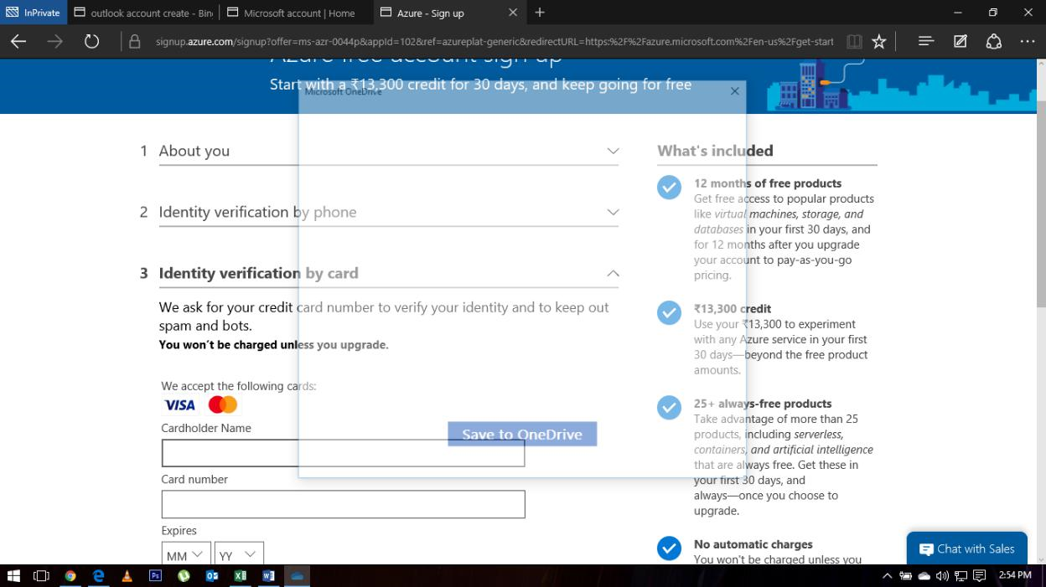

1. Fill card details

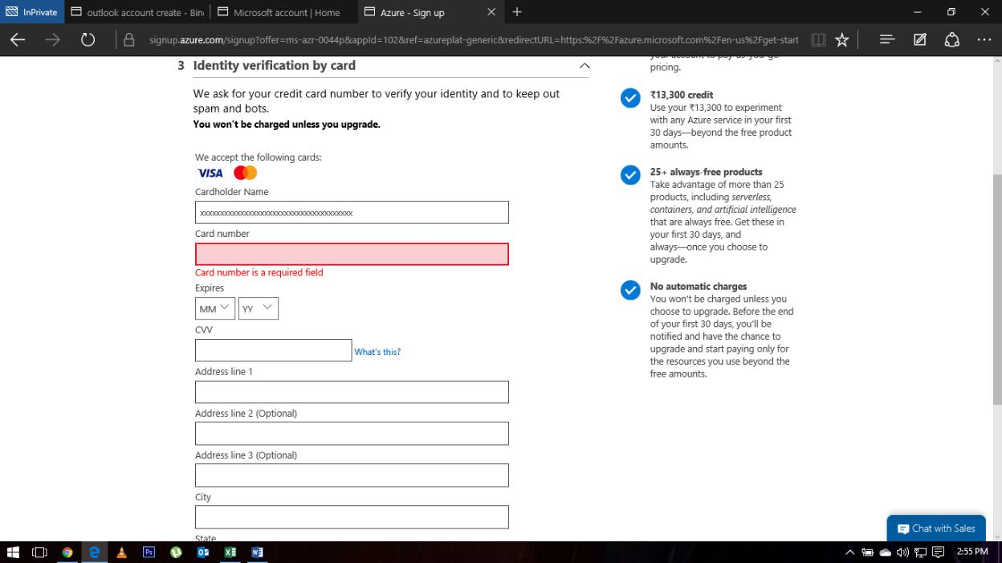

1. Fill details & give OTP.
2. Click “I agree...” & then signup

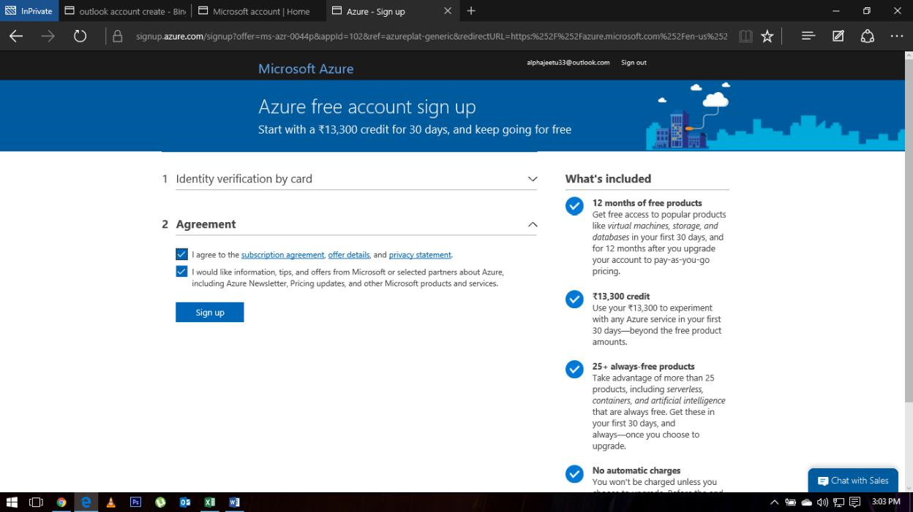

1. Login to: <https://portal.azure.com/#home>
2. Something like this will be visible.

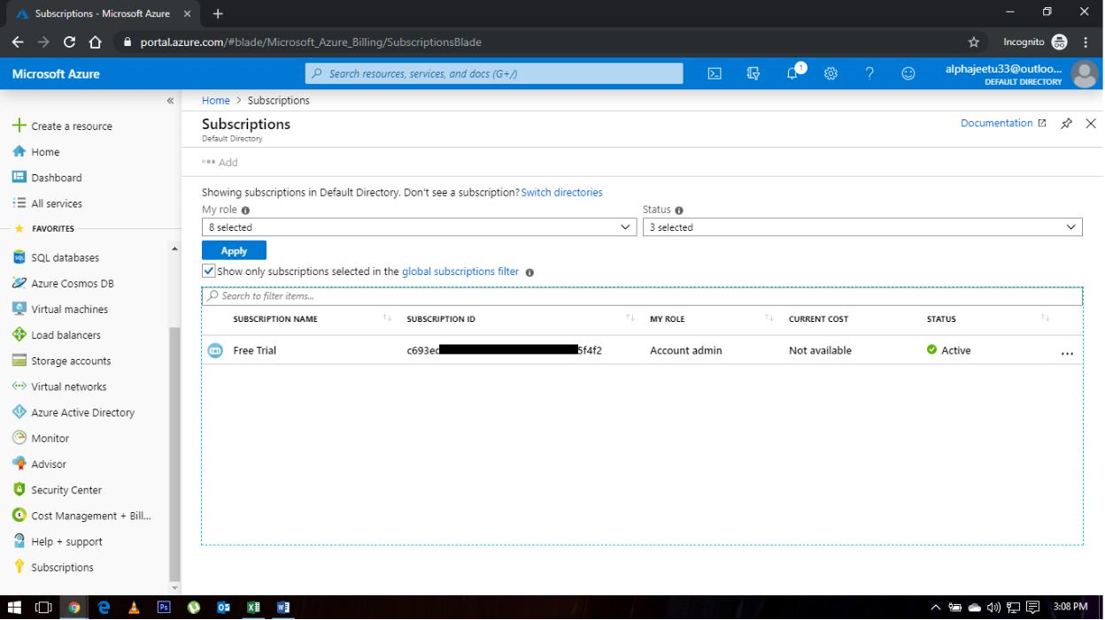

Practice Work No - 2:

|  |  |
| --- | --- |
| **Statement** | Implementing and managing Azure networking. |
| **Objective** | The main objective of the task is to create and manage Azure network using Azure portal. |
| **Outcomes** | After executing this, one should be able to create and manage the azure virtual network (vnet). |
| **Prerequisites** | Working Azure account, Internet |

**[Task]: Create a virtual network using IP address range as (172.16.0.0/16) and with 3 subnets.**

Step1: Create a new resource group in any region of your choice.

Select “Resource Group” on left hand side.

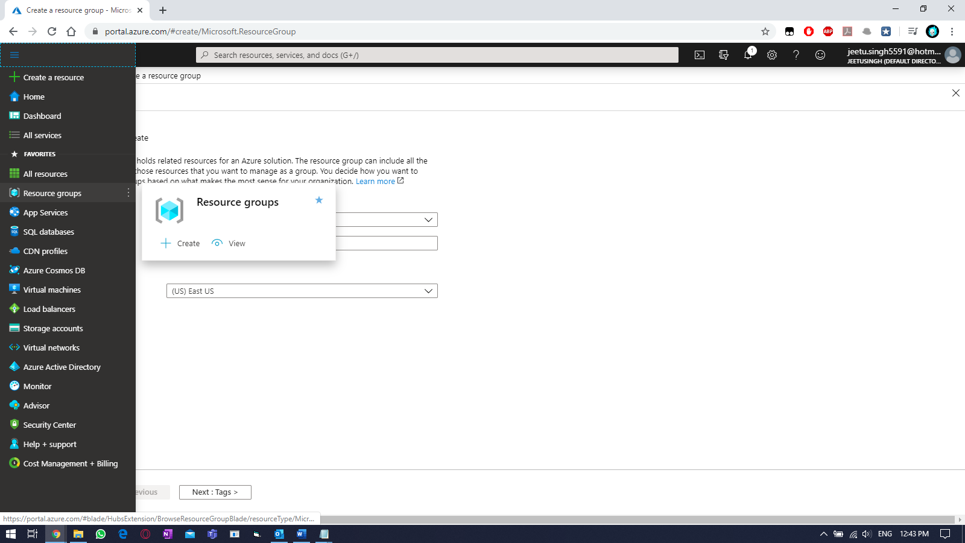

Click on Resource Group and fill the details like RG name & location.

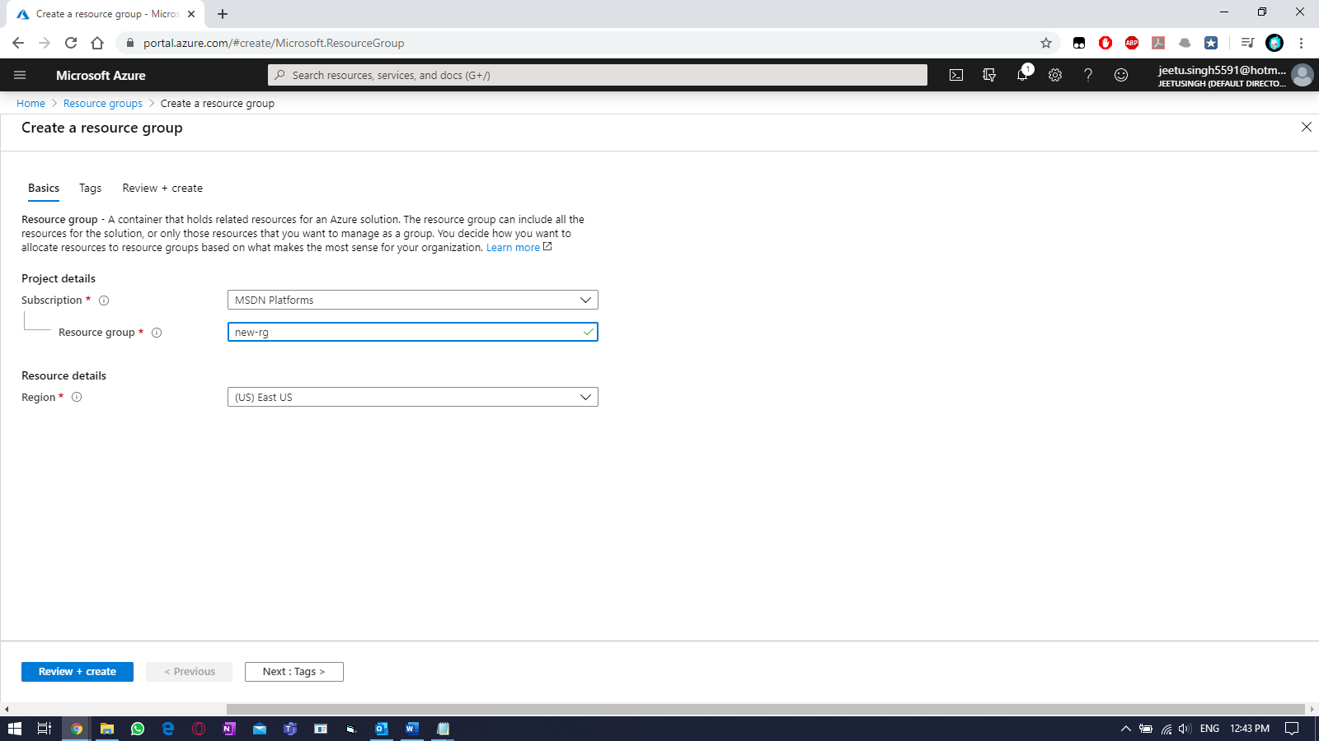

Then click on “TAGS” and fill the tags value (for billing)

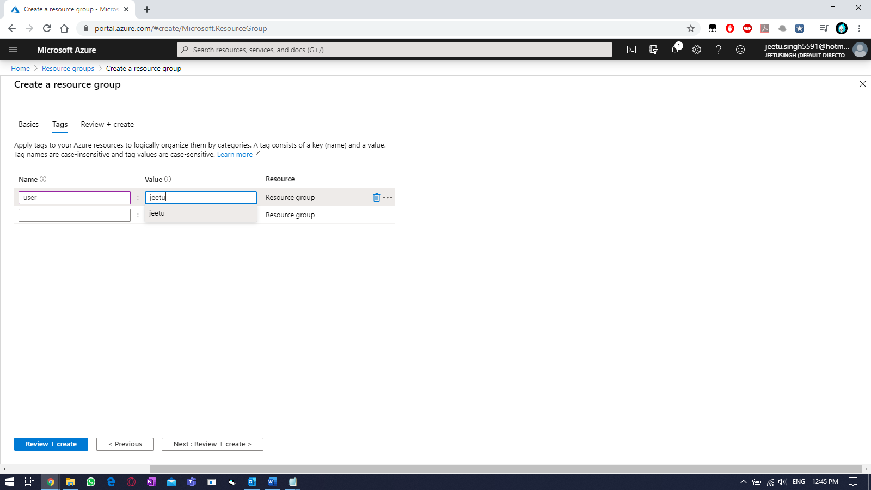

And click on “Next: Review + Create >”

Click on “Create” once validation is passed.

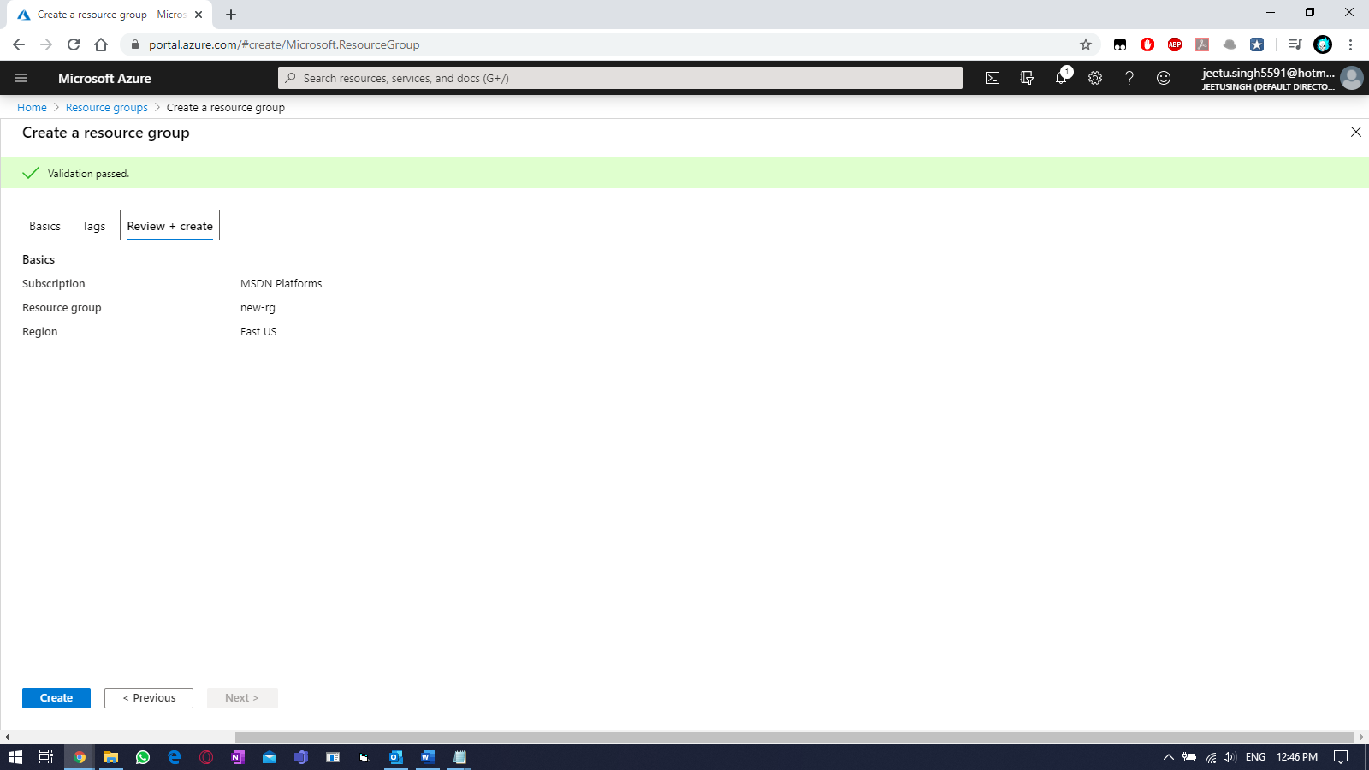

Verify.

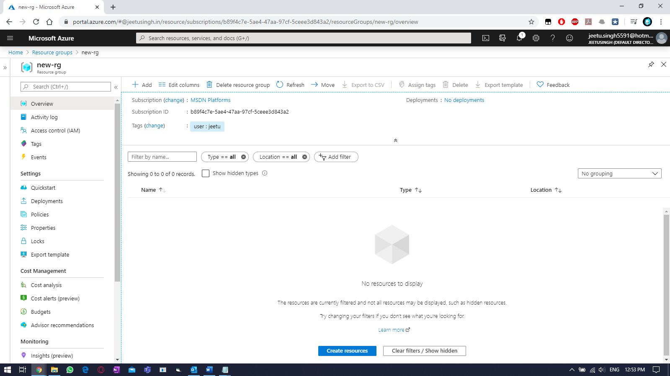

Step2: Create a virtual network (vnet) in the above RG using same region/location as RG.

On left side, click on ellipses (3 small lines) & select virtual network.

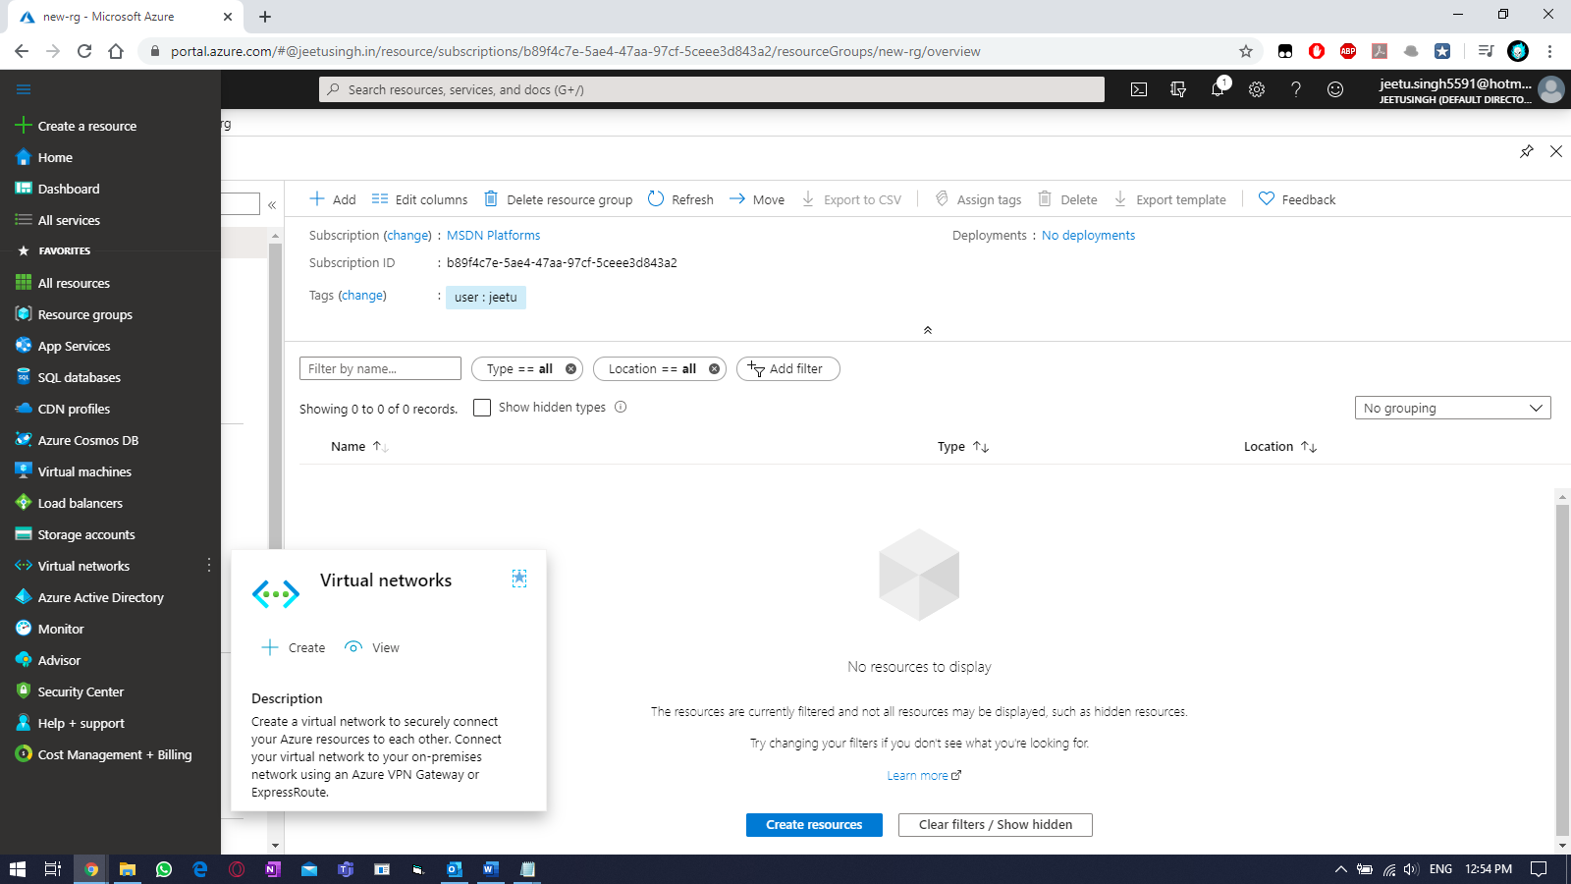

To create a new vnet, click on “+ADD” or “Create Virtual Network” button. Fill the required details.

* Resource Group (RG) 🡪 new-rg
* Name 🡪 newrg-vnet
* Region 🡪 ‘East US’

And then click on “Next: IP Addresses >”

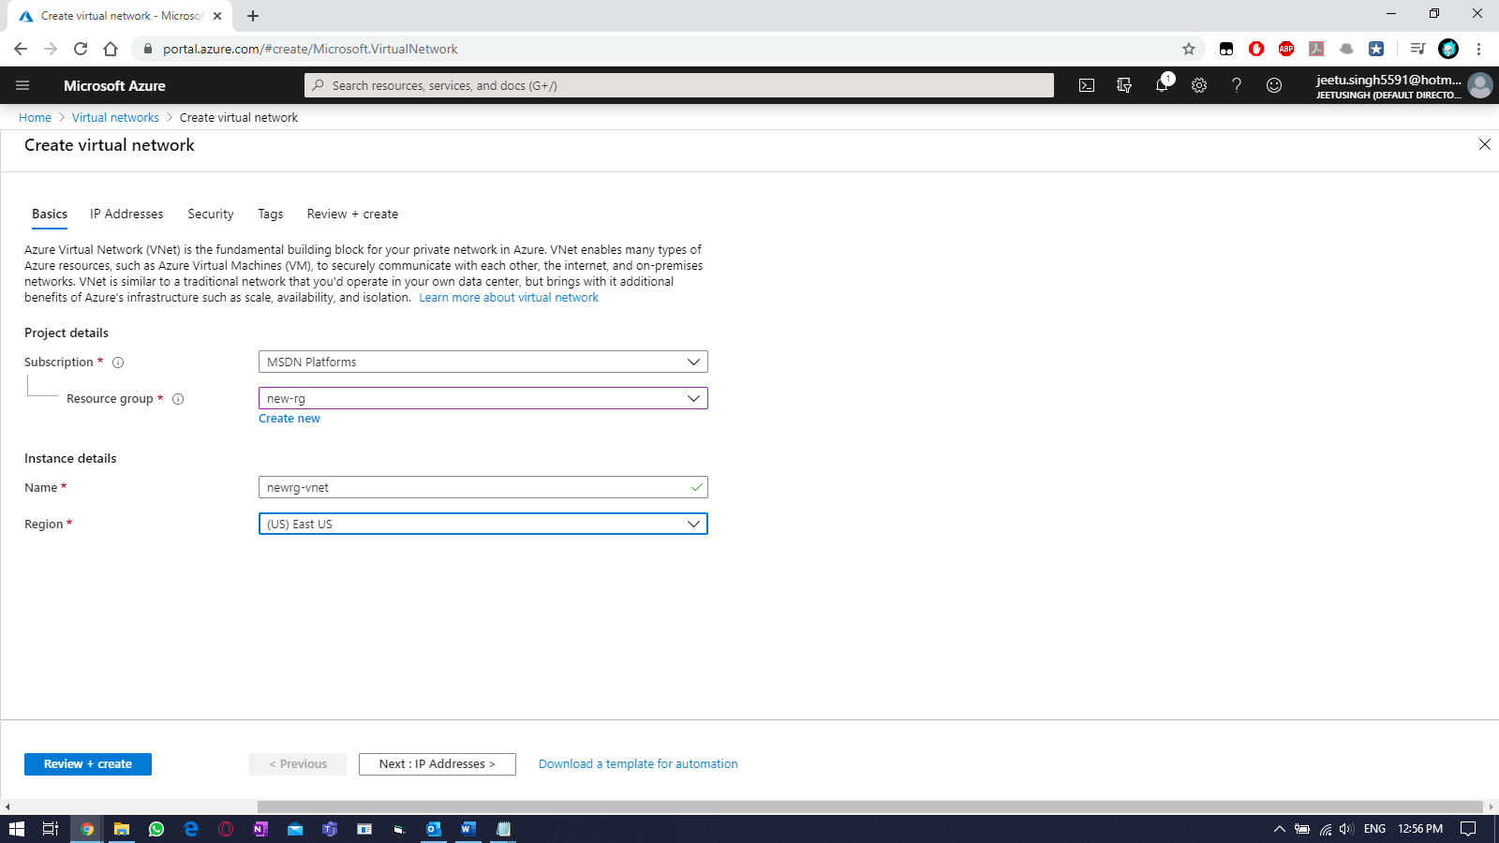

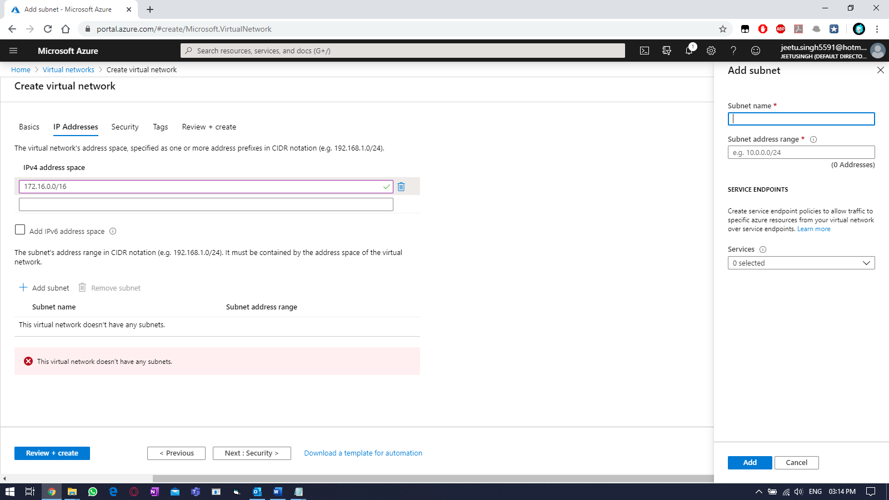

Creating subnets:

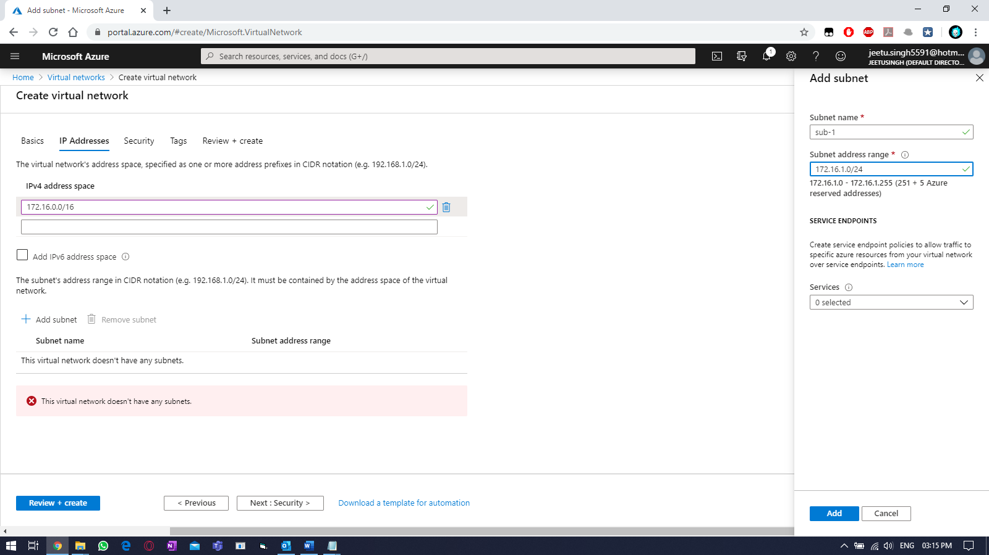

Creating 2nd subnets.

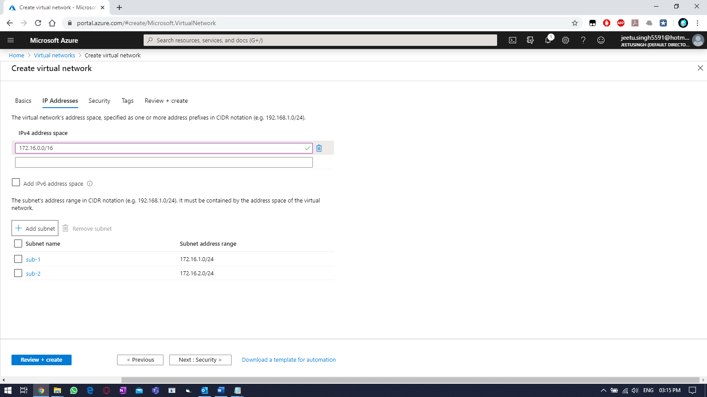

Select defaults for “Security”

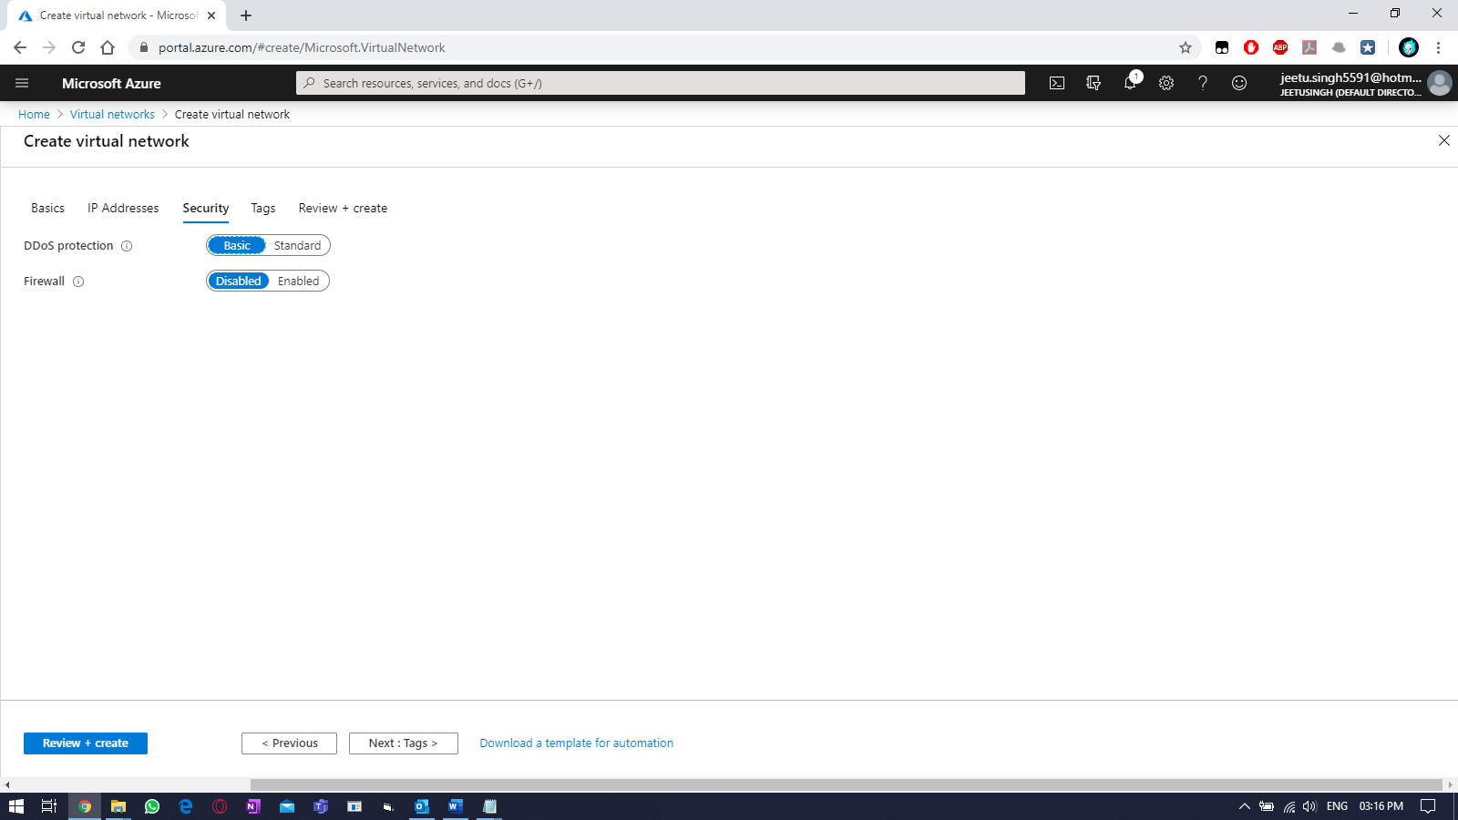

Select the tags:

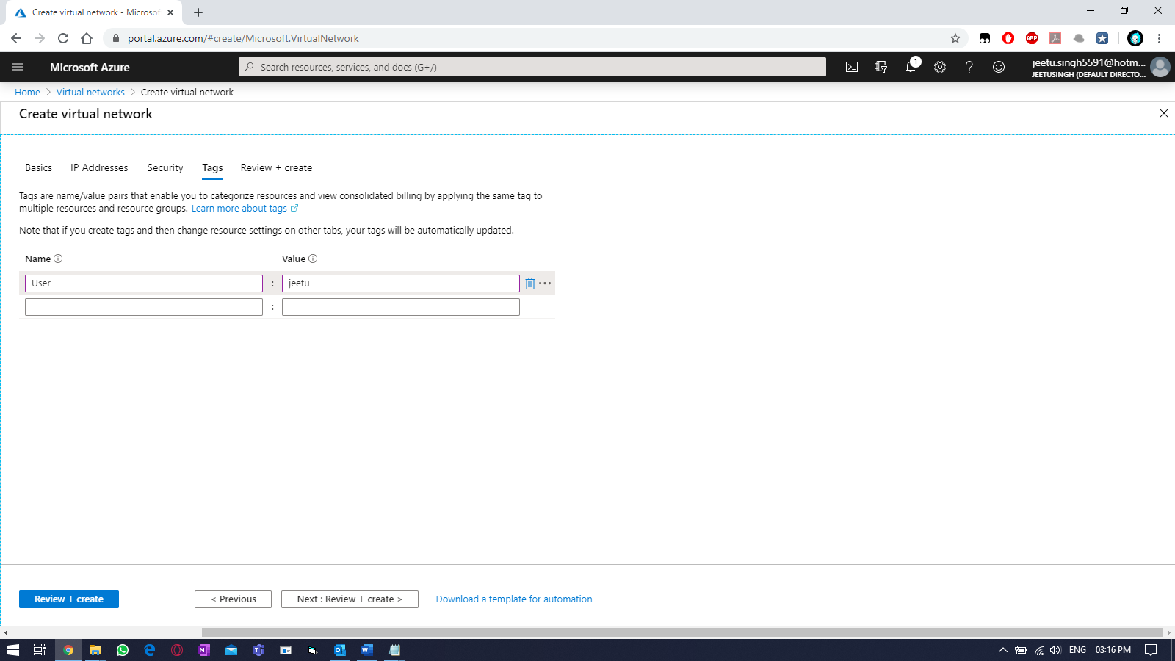

Once validation passed, click on “create”.

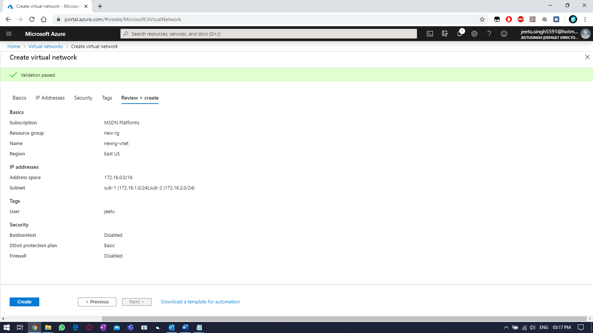

Wait for the deployment to get finished.

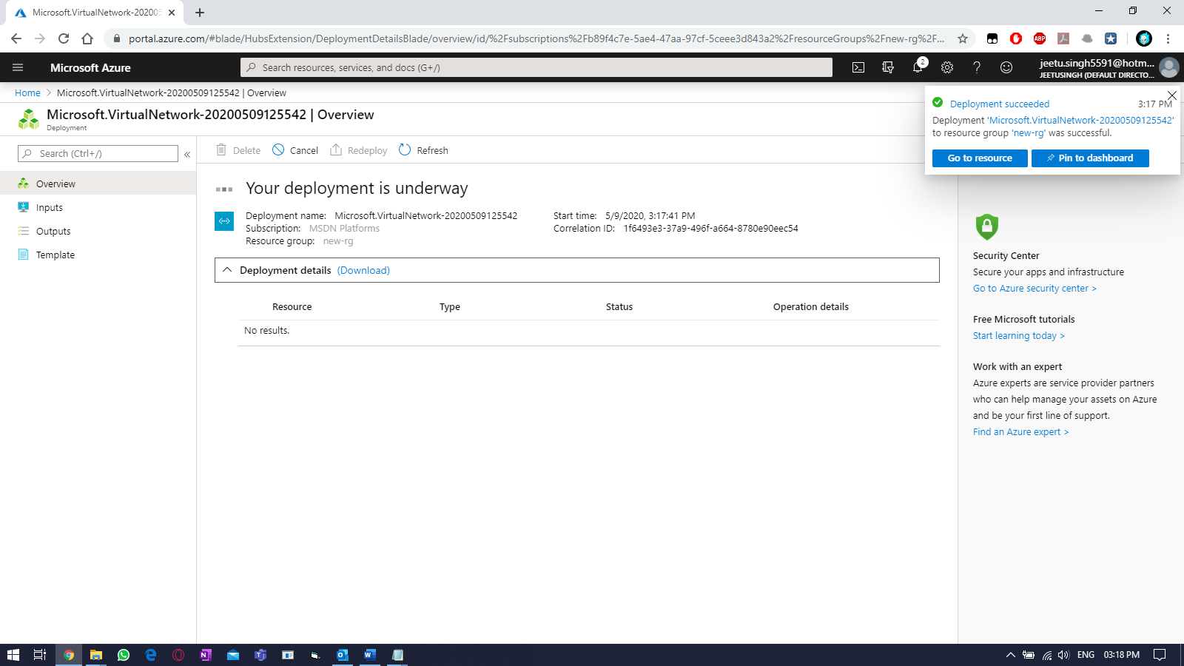

Click on “Go to resource”

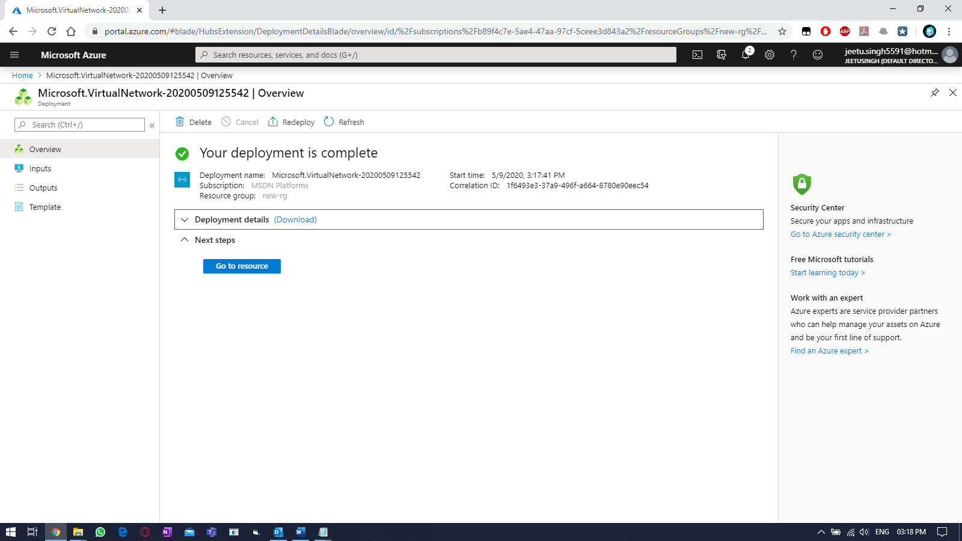

On left side, select Virtual network and select your vnet.

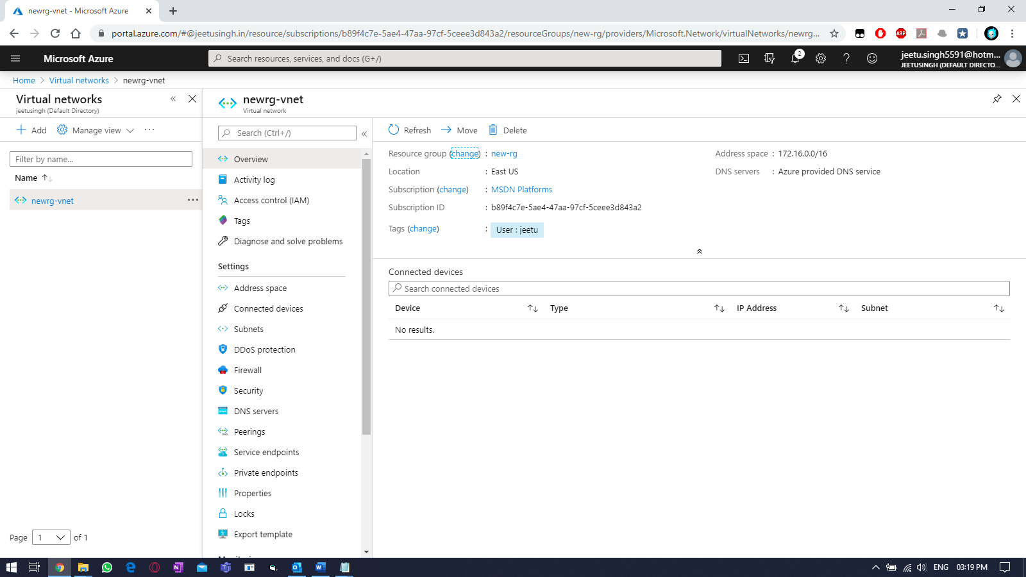

Adding 3rd subnet and adding a DNS server.

Select “subnets” within the vnet you created earlier, select “+Subnet” to add another one.

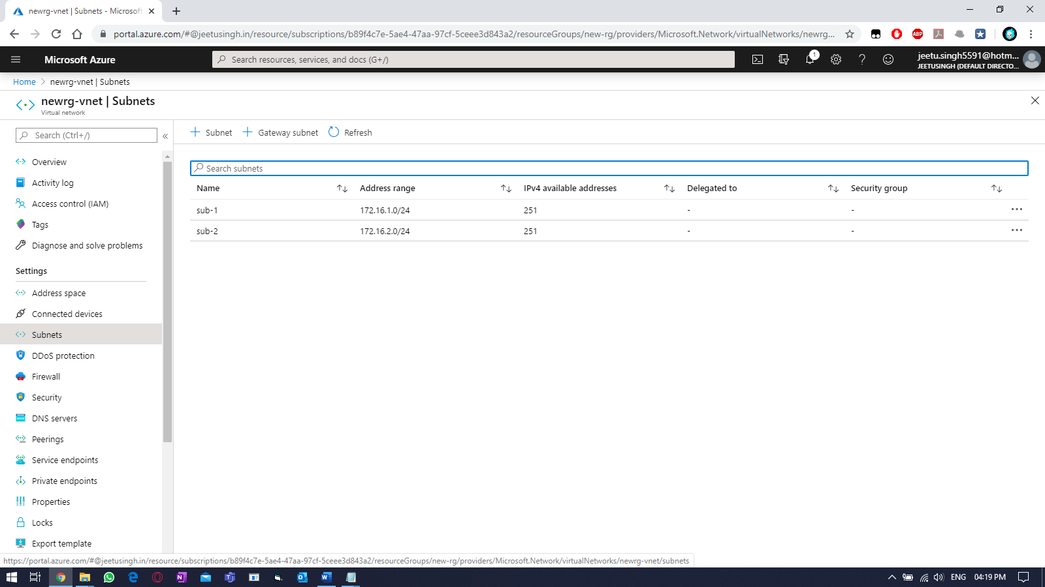

Fill required details. Then select “OK”

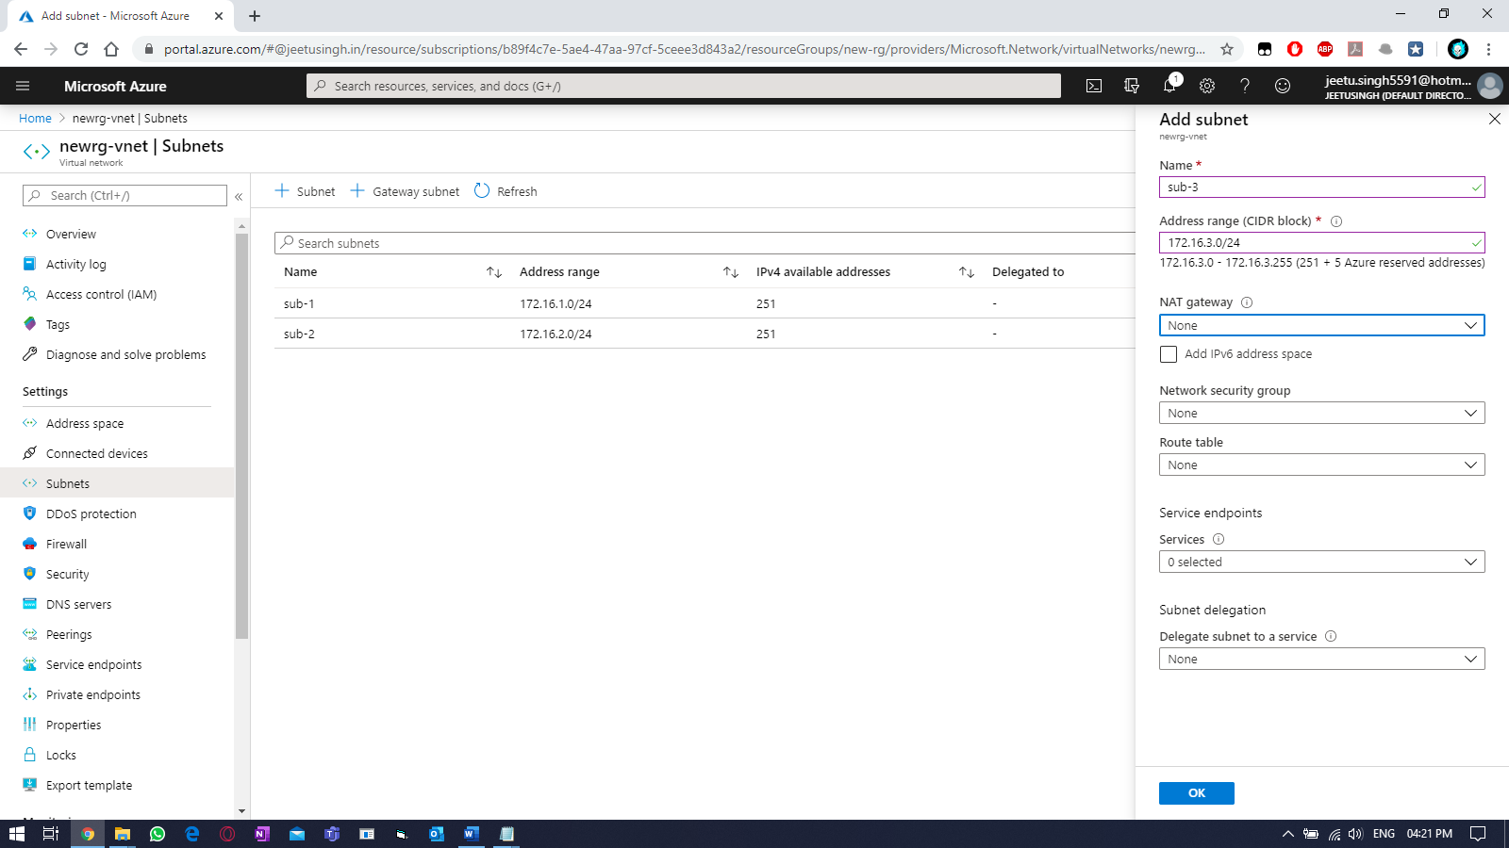

& verify.

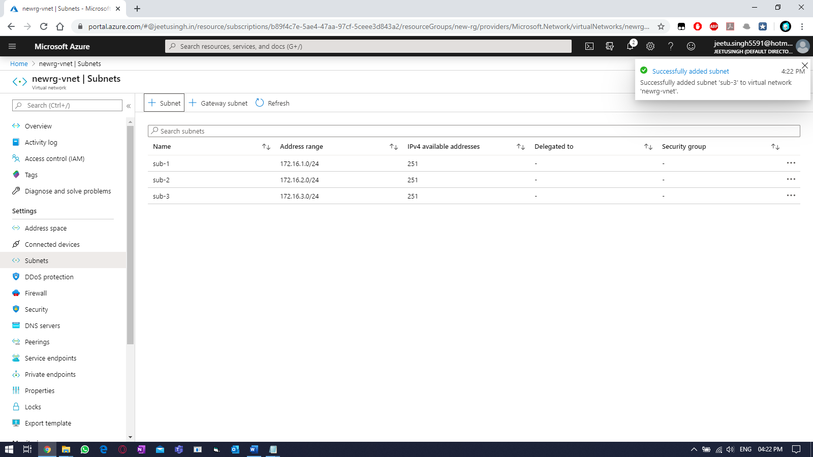

Adding DNS for the VNET.

Select “DNS servers” within your vnet & select “custom”, then fill your required valid DNS servers.

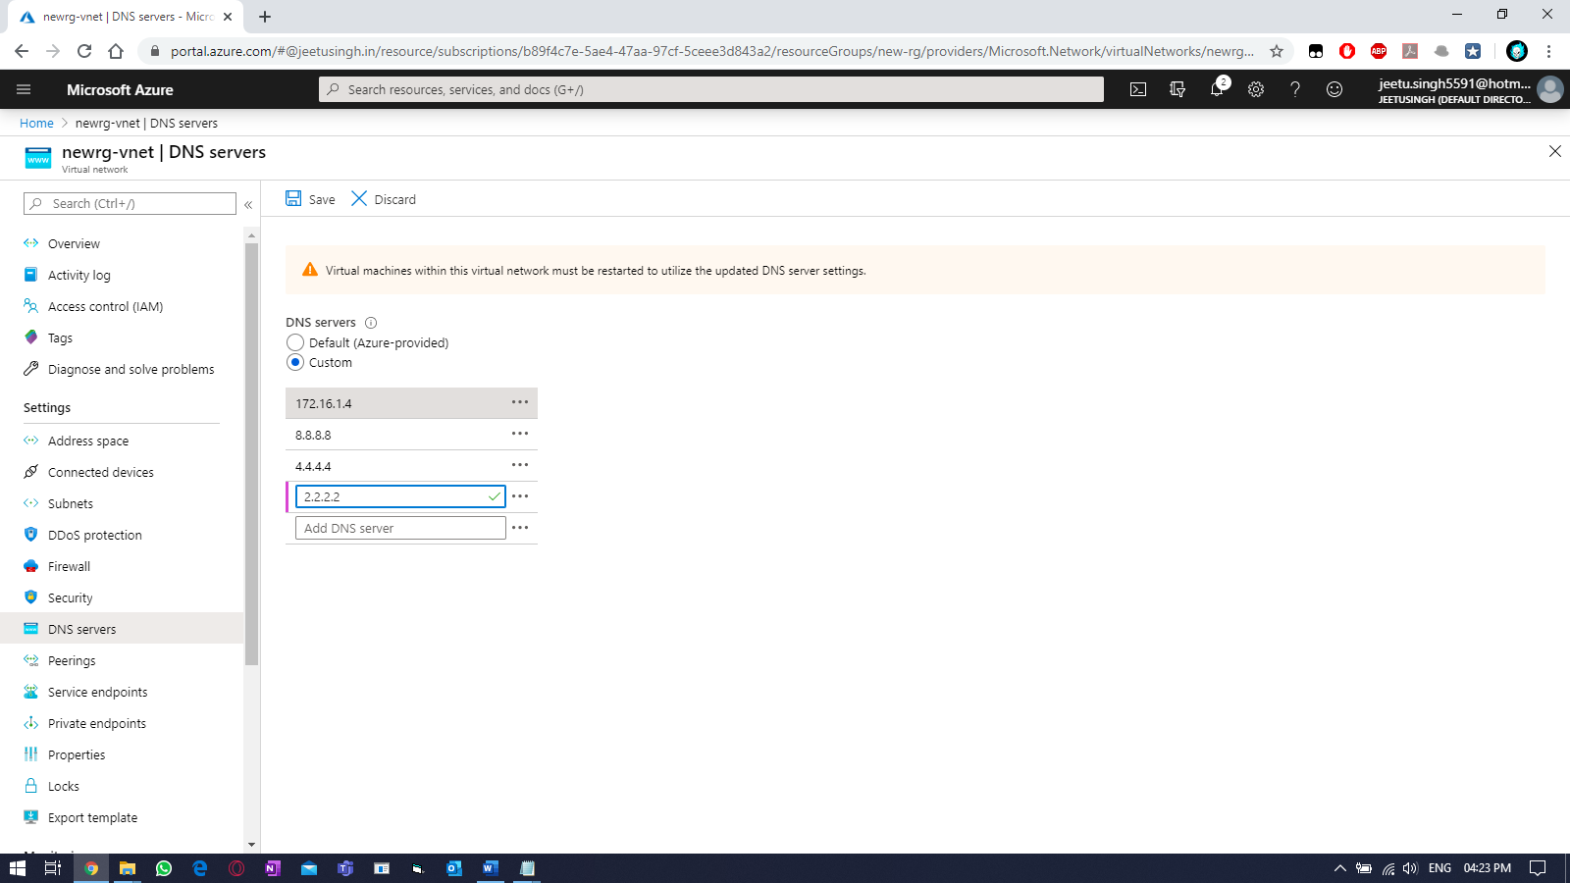

Practice Work No - 3:

|  |  |
| --- | --- |
| **Statement** | Planning and implementing storage, backup, and recovery services. |
| **Objective** | The main objective of the task is to create and manage Azure storage account using Azure portal. |
| **Outcomes** | After executing this, one should be able to create and manage the azure storage account. |
| **Prerequisites** | Working Azure account, Internet |

**[Task]: Create a new storage account and also use the virtual network created earlier.**

Create a new storage account.

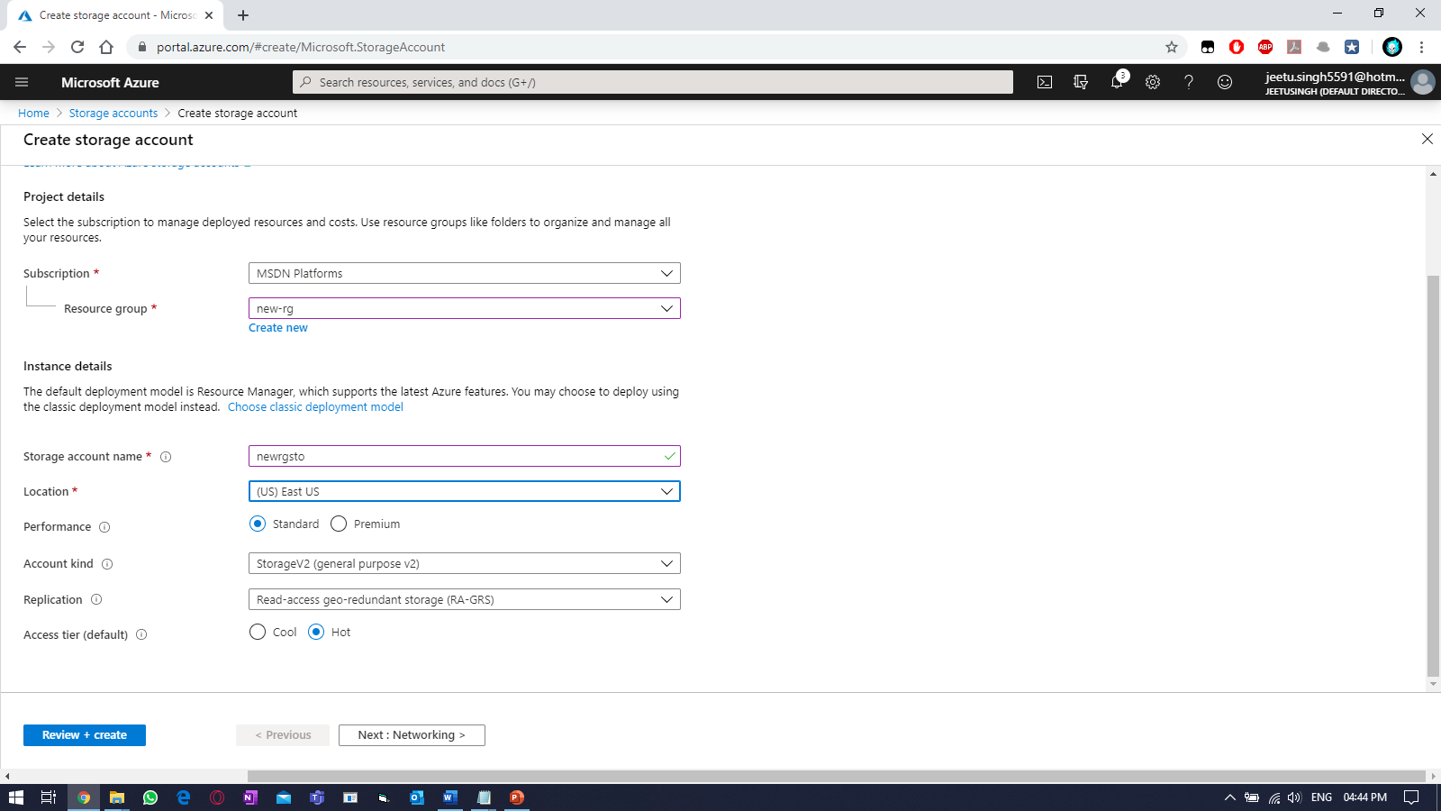

Select public endpoint (all networks), then Click advanced >

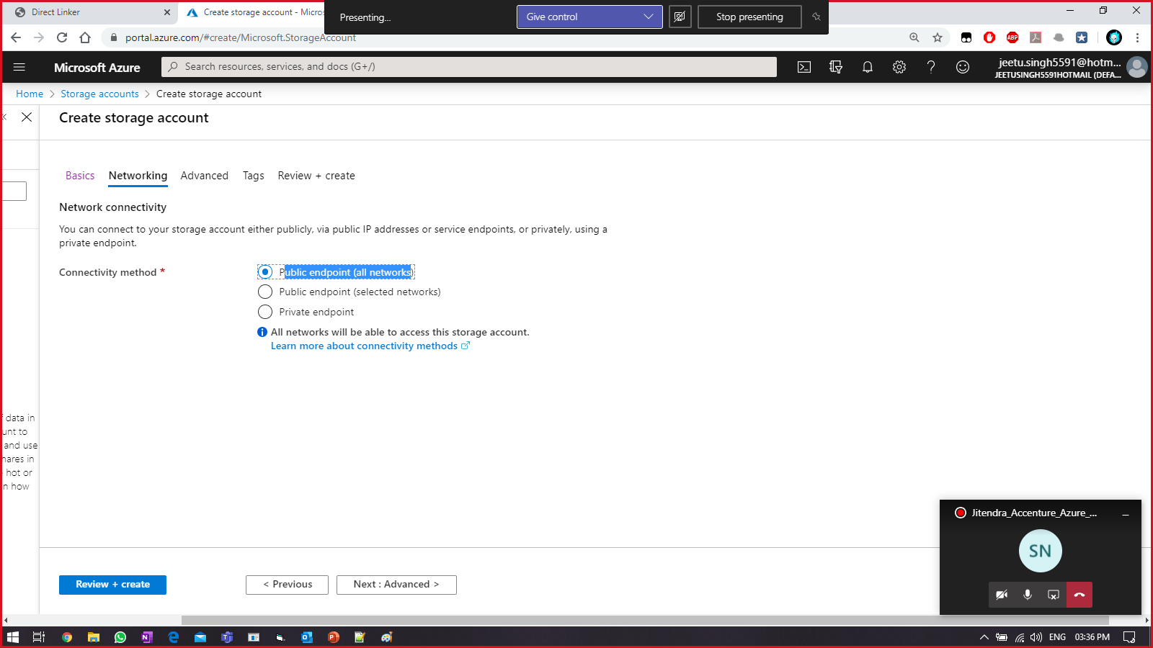

Nothing to change in advanced, Click Next: TAGS >

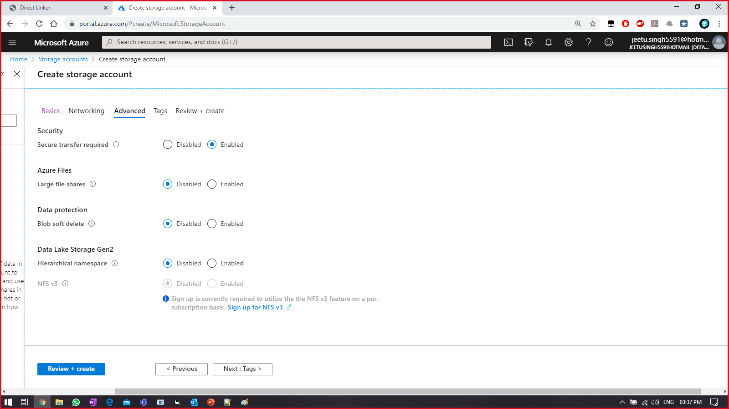

Select your tag name & value, Click on Next: review + create >

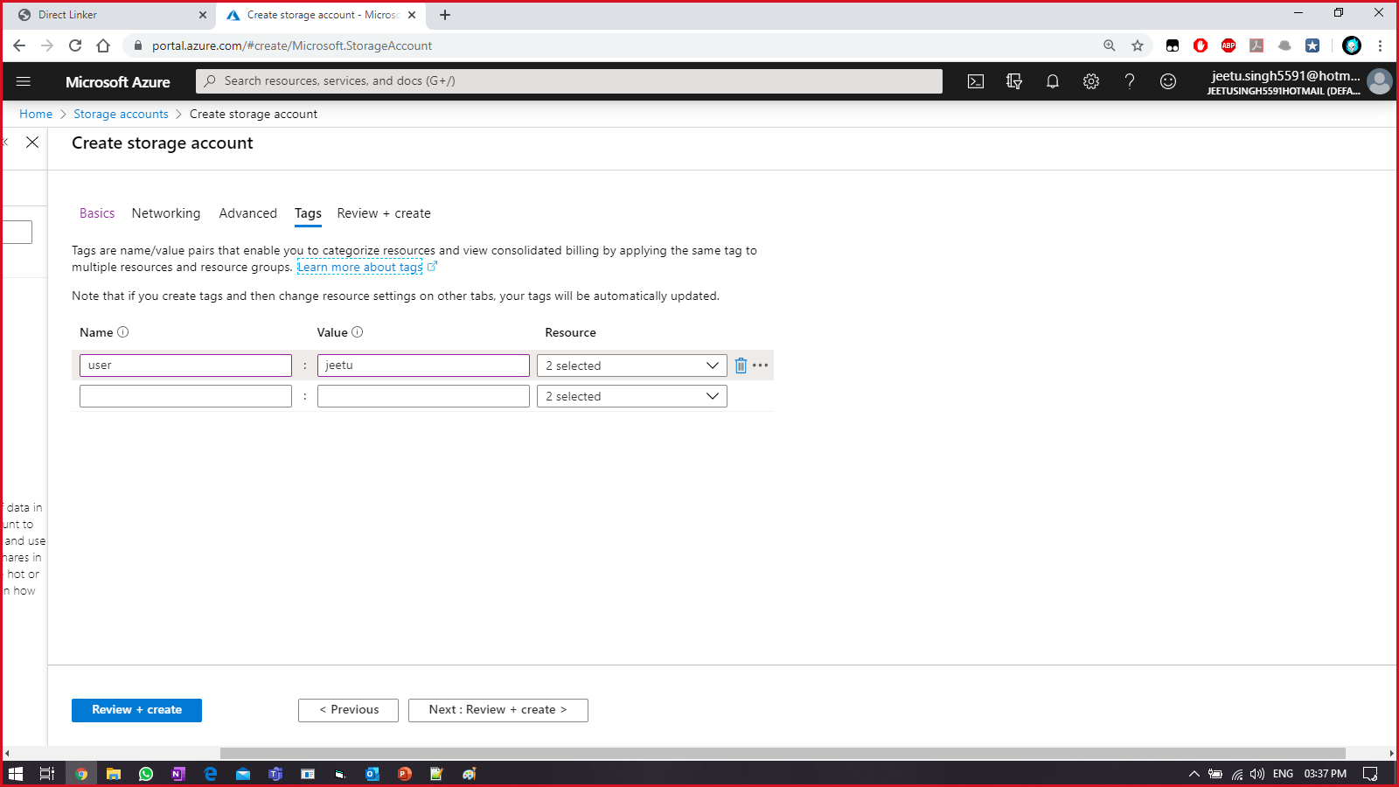

Wait until you get VALIDATION PASSED, then click on CREATE.

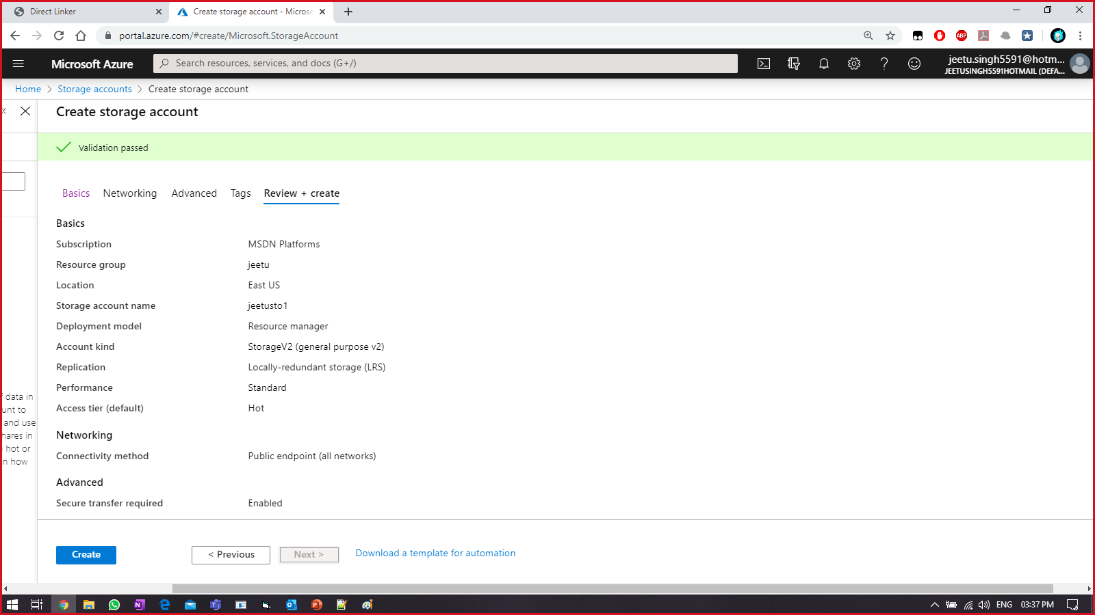

Wait until its finished.

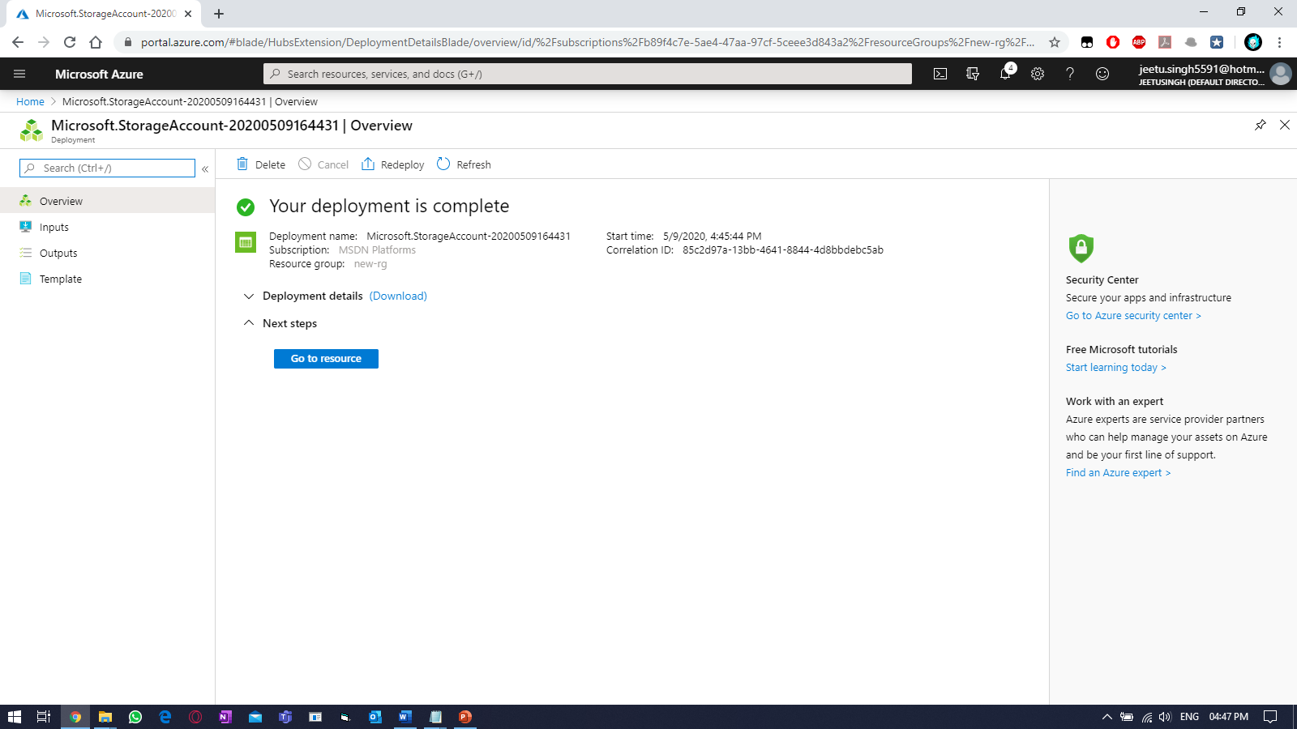

Practice Work No - 4:

|  |  |
| --- | --- |
| **Statement** | Implementing virtual machines. |
| **Objective** | The main objective of the task is to create and manage Azure virtual machine (VM) using Azure portal. |
| **Outcomes** | After executing this, one should be able to create and manage the azure virtual machine (VM). |
| **Prerequisites** | Working Azure account, Internet |

**[Task]: Create a new VM using the vnet you created earlier (newrg-vnet) and use first subnet (sub-1) for the VM. Also use the storage created earlier. Connect to the VM using credentials provided earlier at the time of VM creation. And perform backup of the current VM.**

Select the virtual machine (VM) tab from left side.

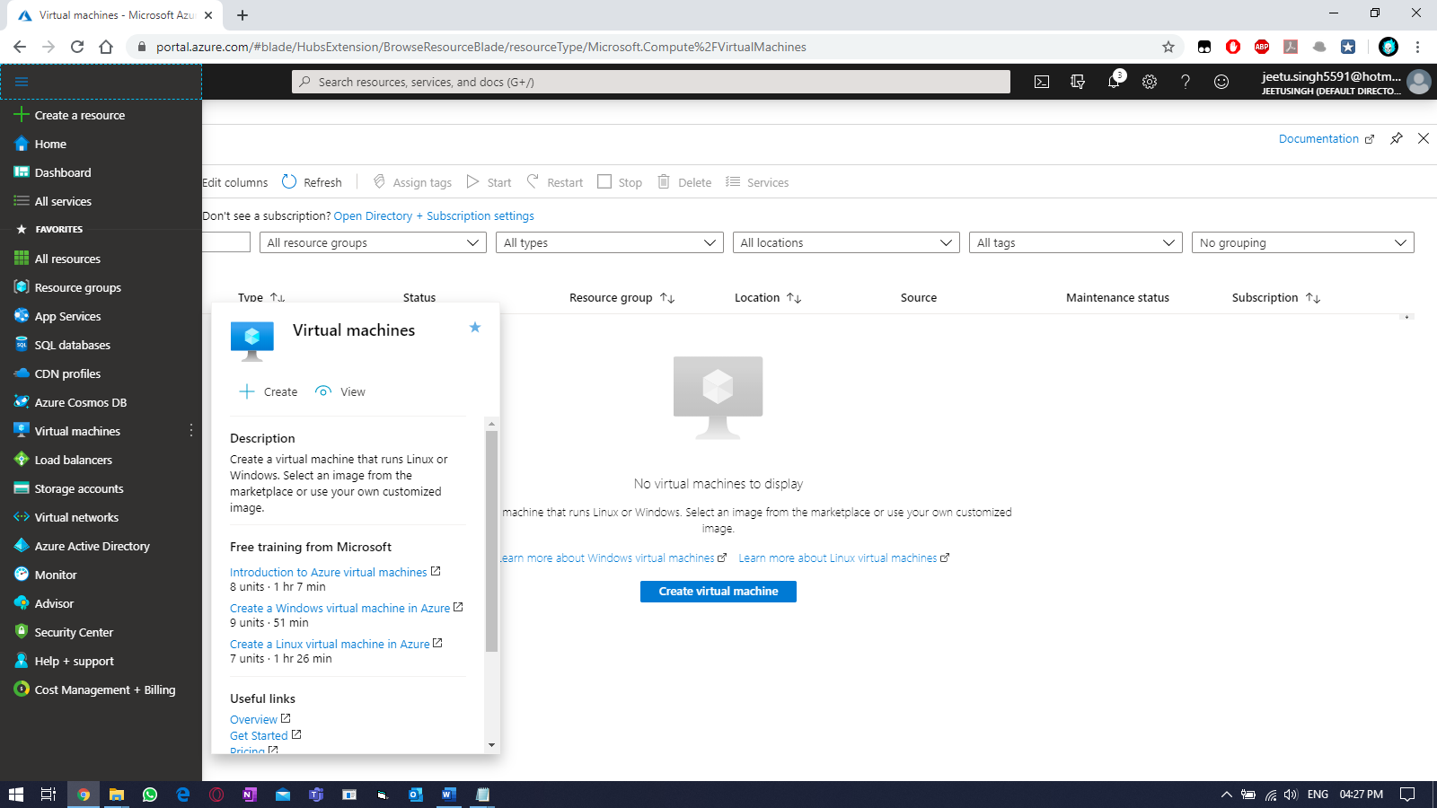

Click on “add” & fill the required details to create the VM.

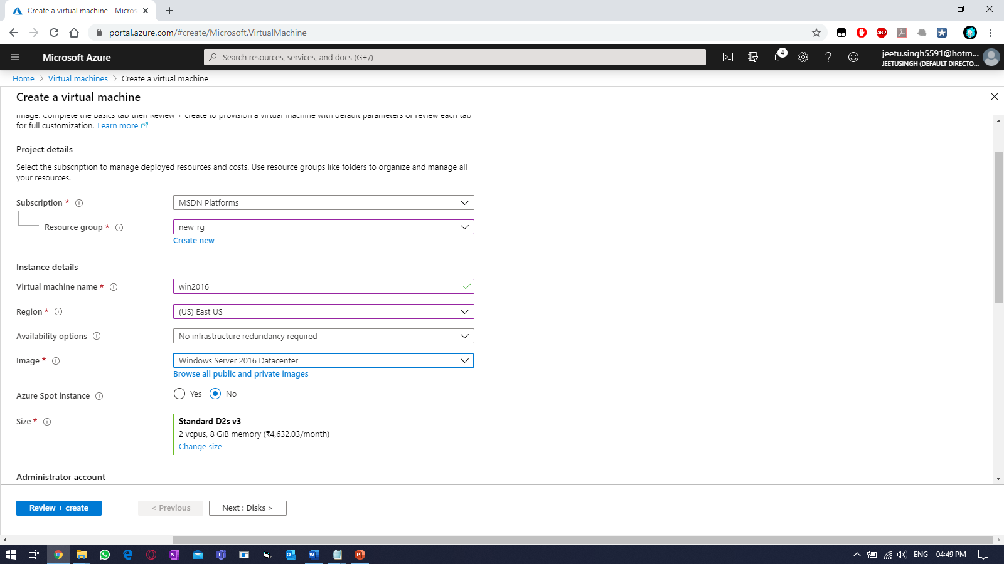

Provide username & password for the VM:

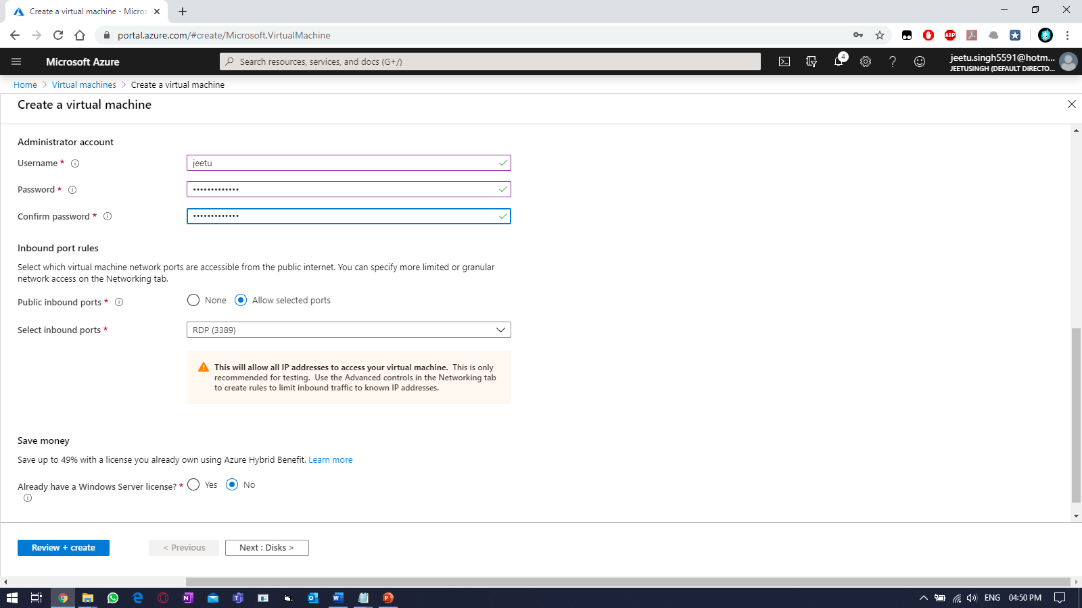

Click “Next: Disk >”

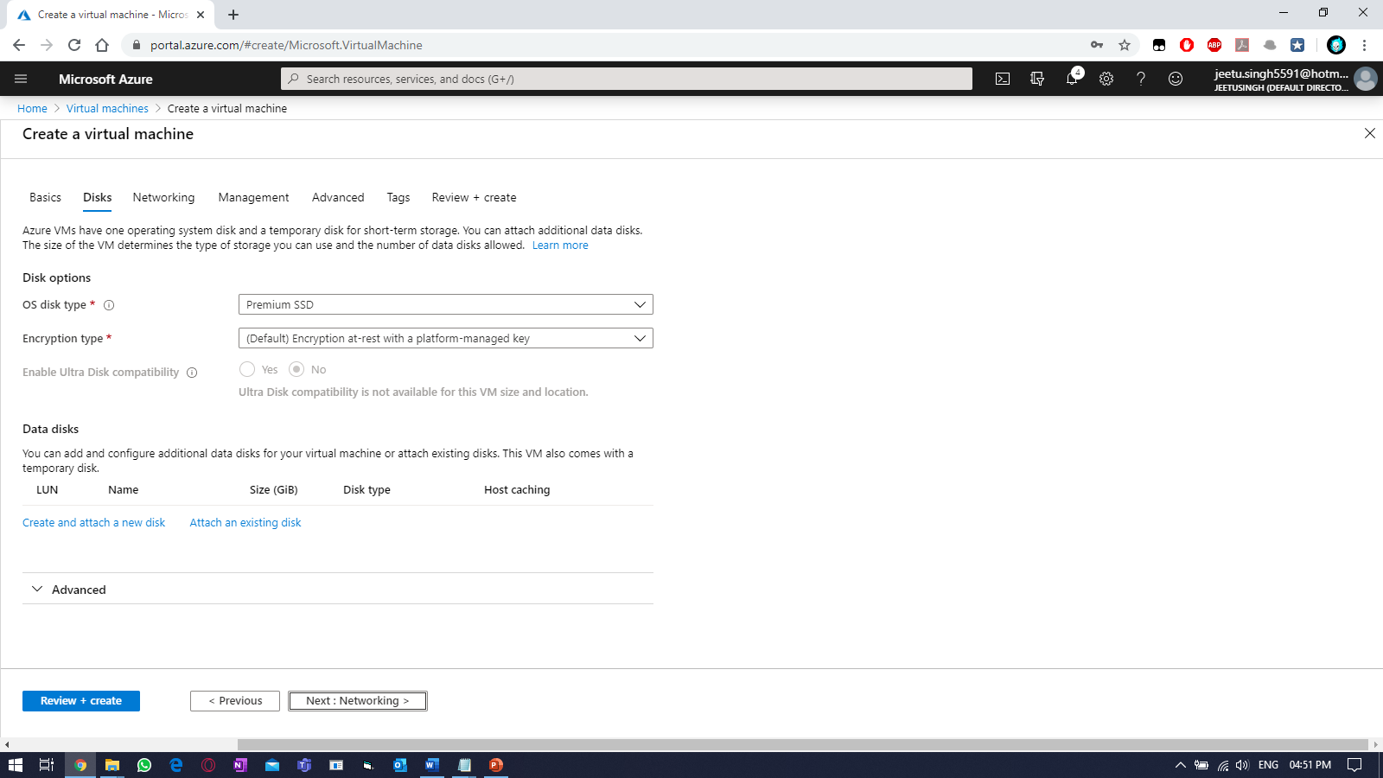

No changes required. Click “Next: Networking >” & select the virtual network created earlier and enable RDP port.

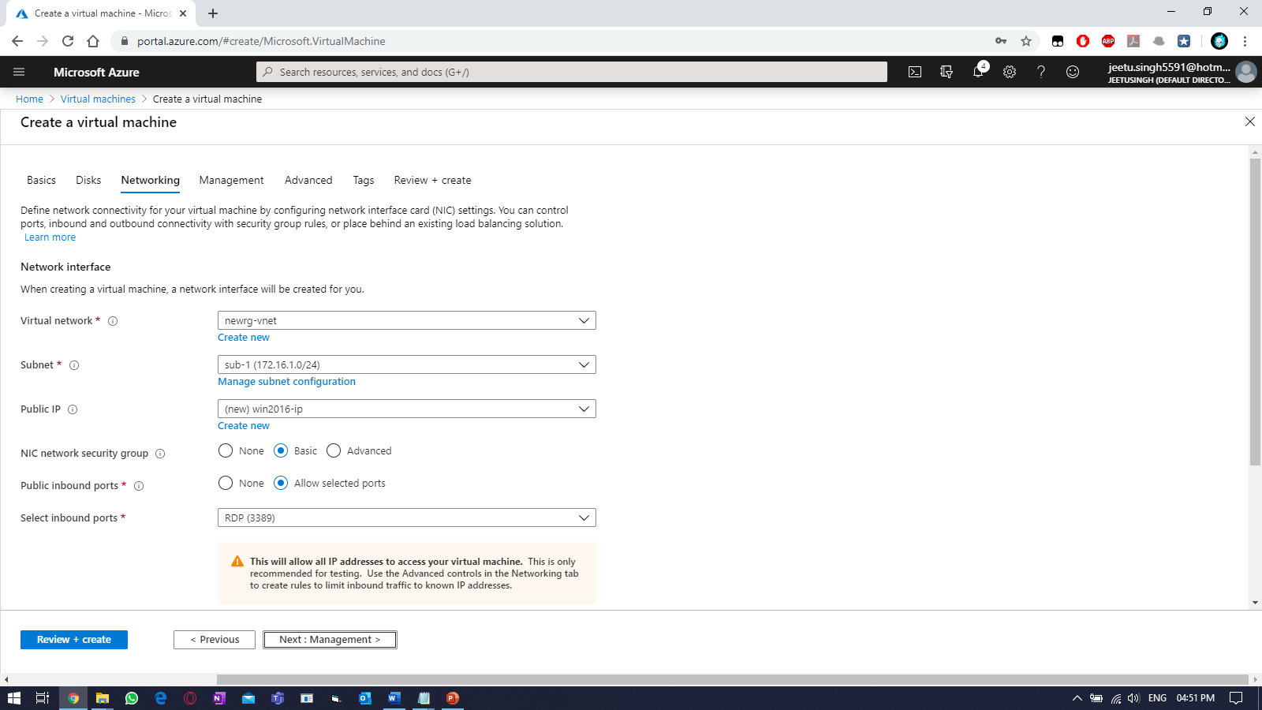

Select the storage account you created earlier and click “Next: Advanced >”

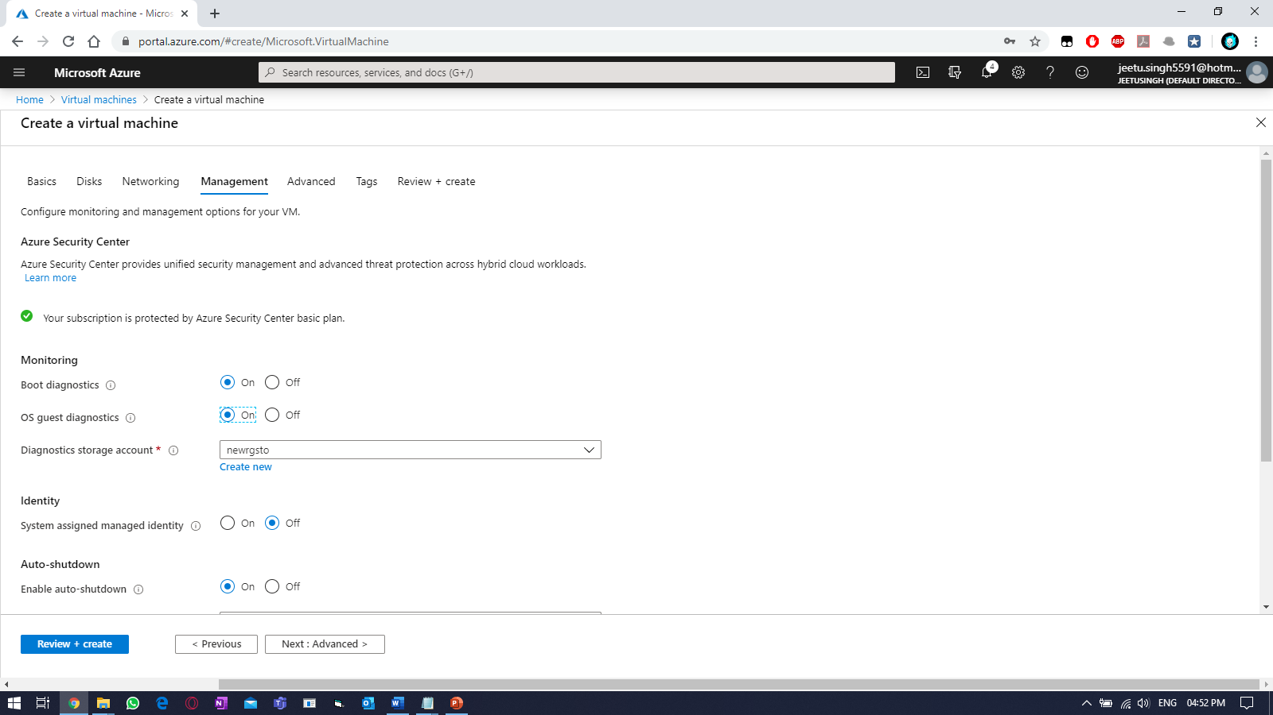

Nothing to change to in advanced, as no extension are to be installed.

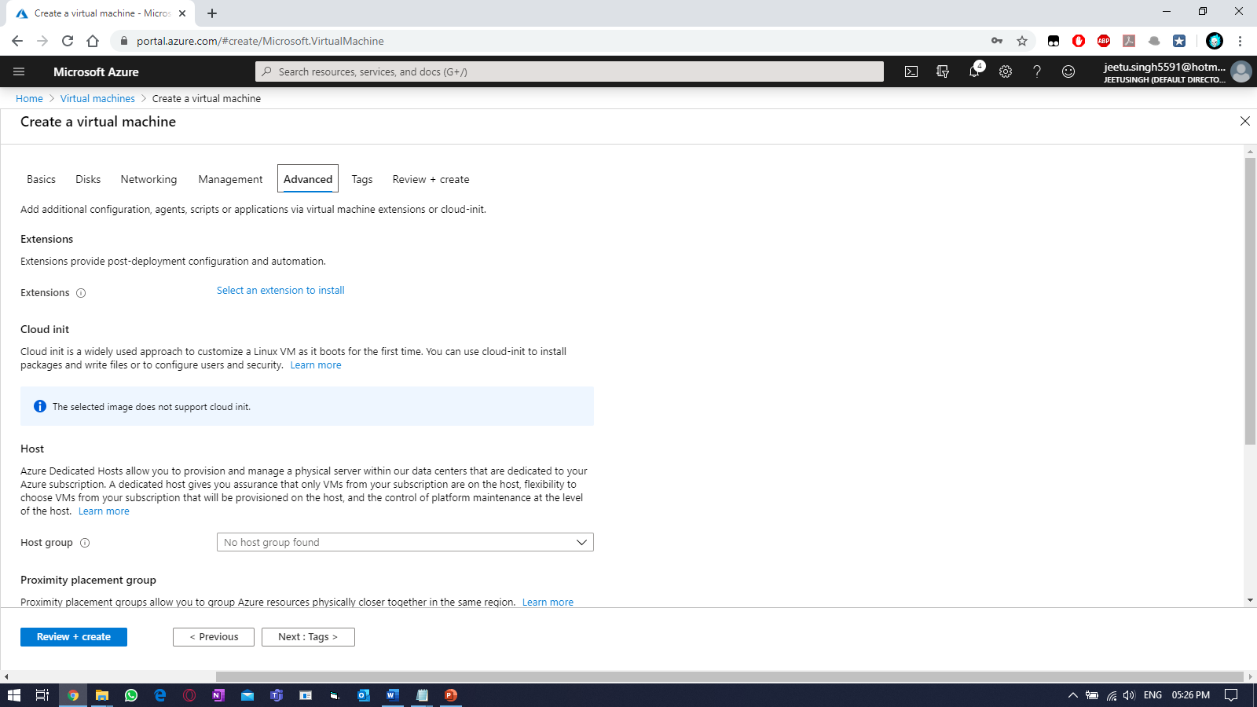

Attach the tags and create “Next: Review + Create”

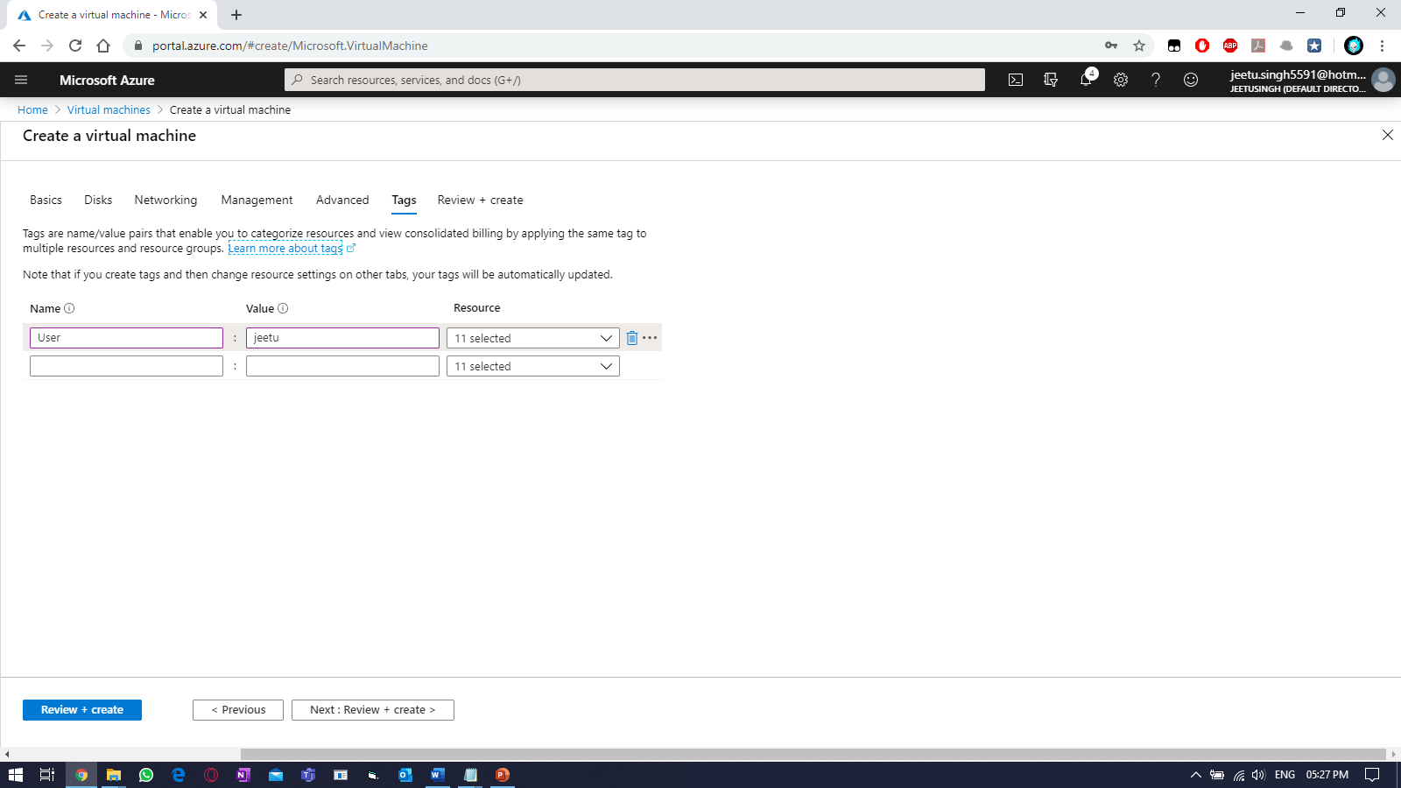

If validation is passed, then click “Create”.

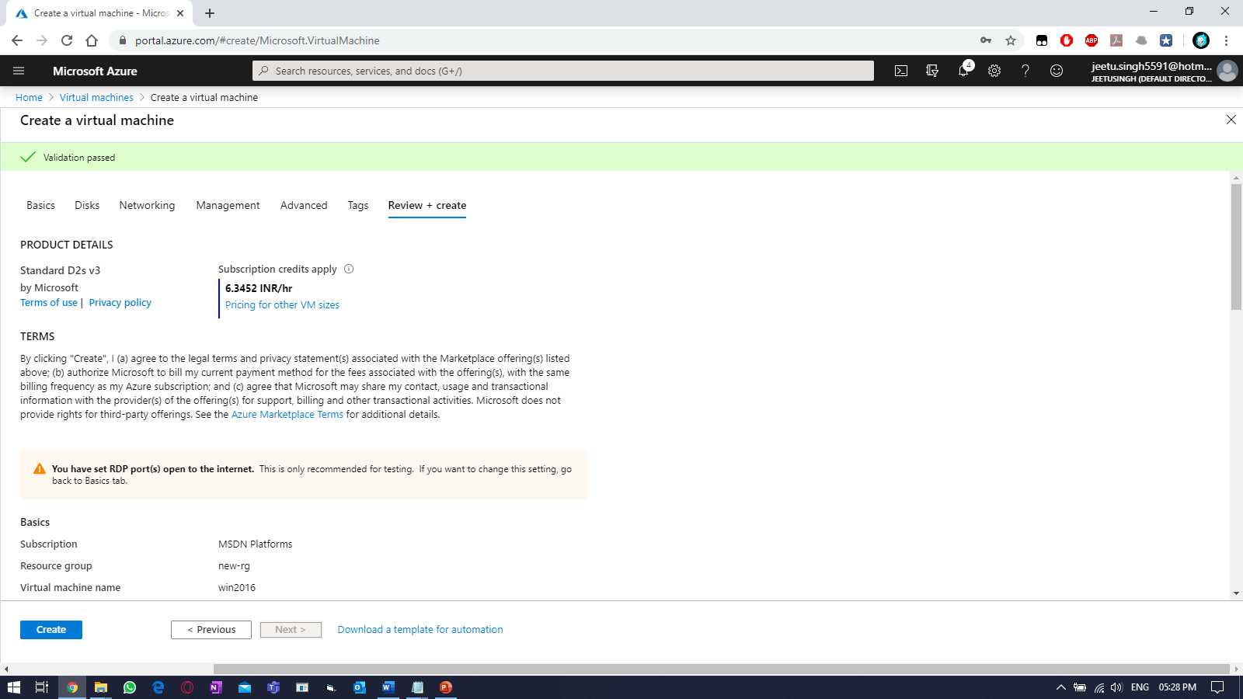

Click to “Go to resource”, once finished.

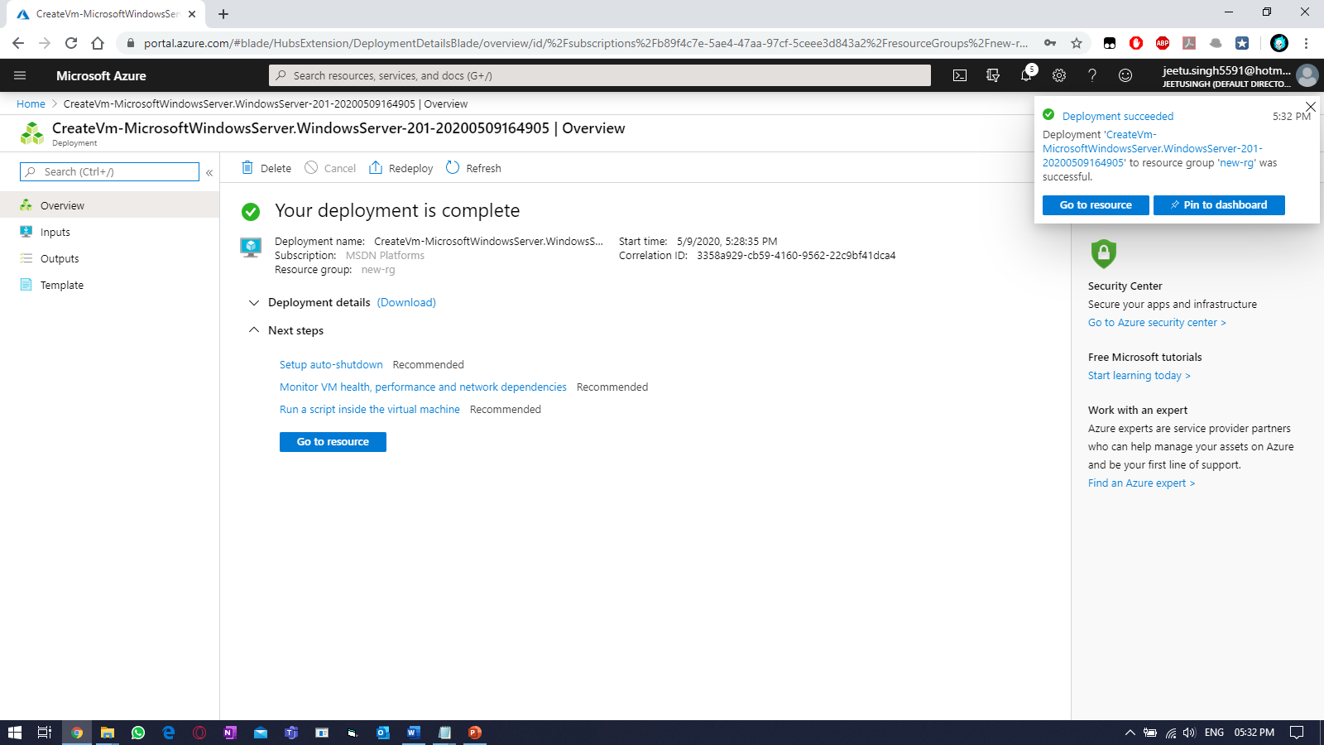

To connect to the VM, click on “CONNECT” and select RDP.

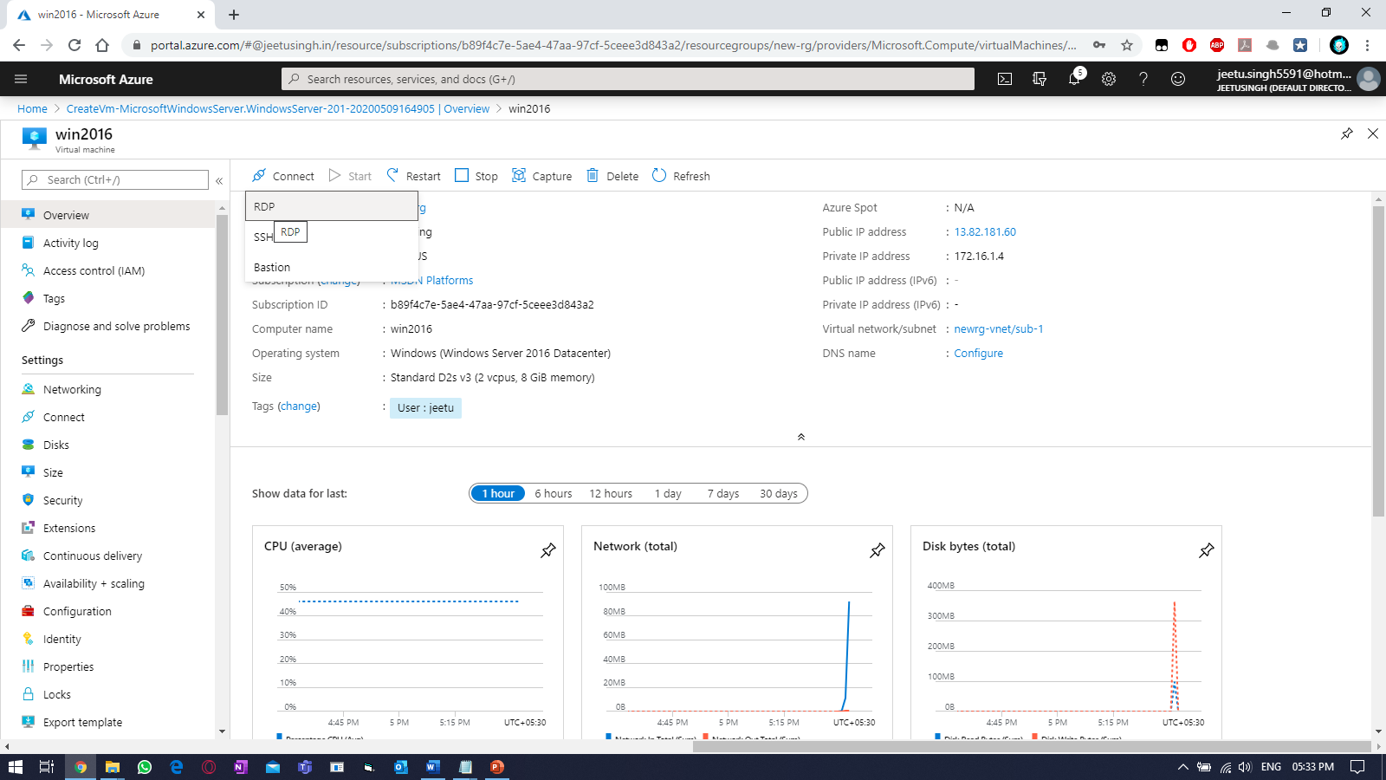

Download RDP & provide username & password.

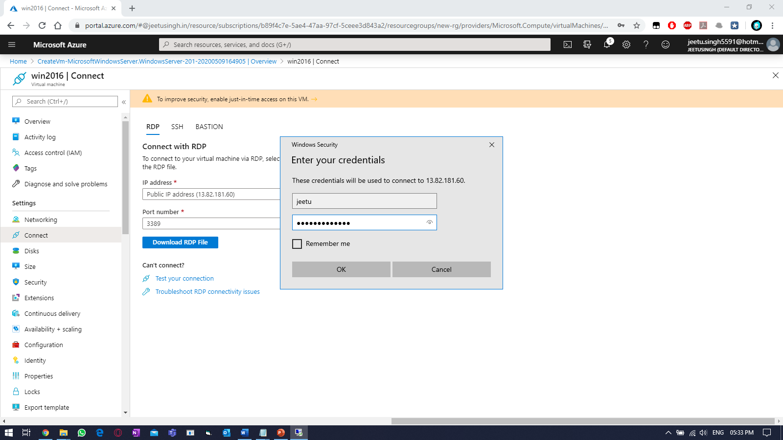

Verify:

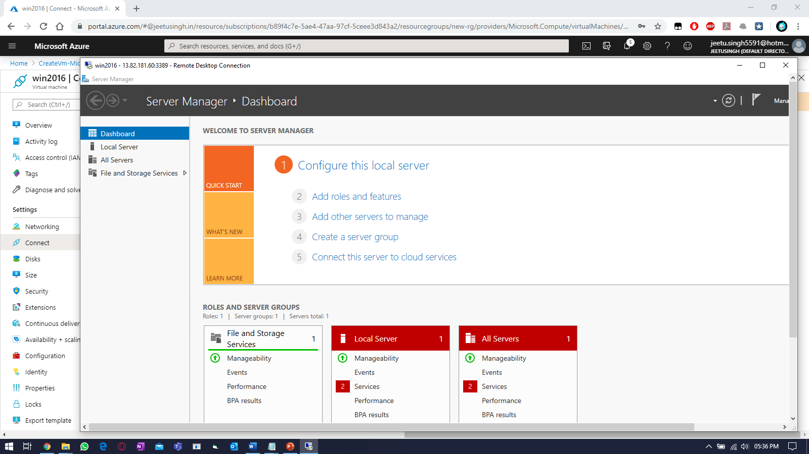

Perform the backup for the any windows VM. Select a VM & search for “backup” blade.

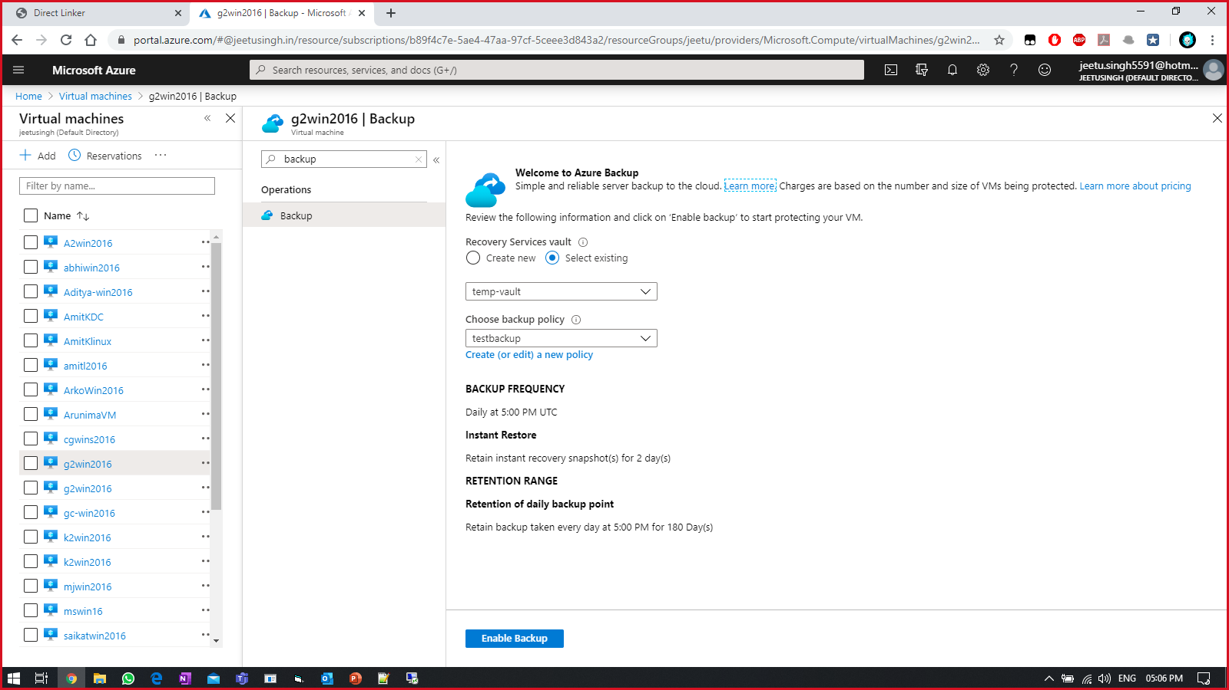

Enable backup & create backup policy.

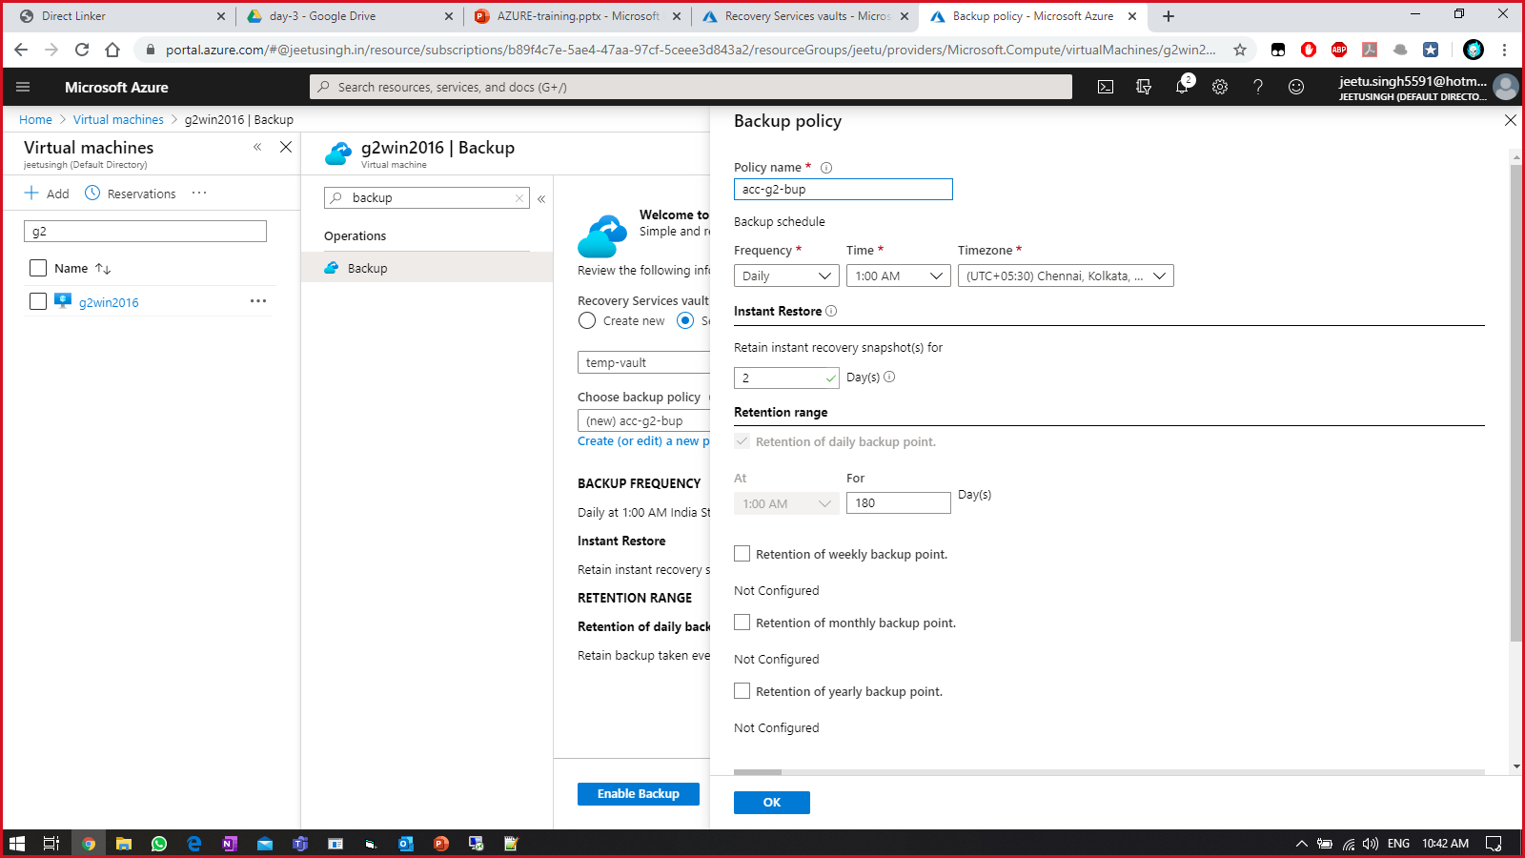

Once backup is ready,

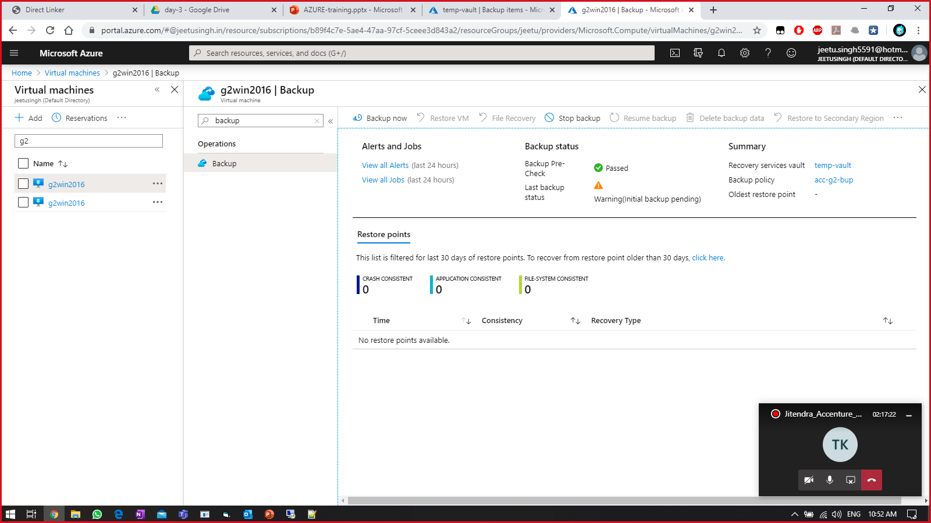

Select backup now, 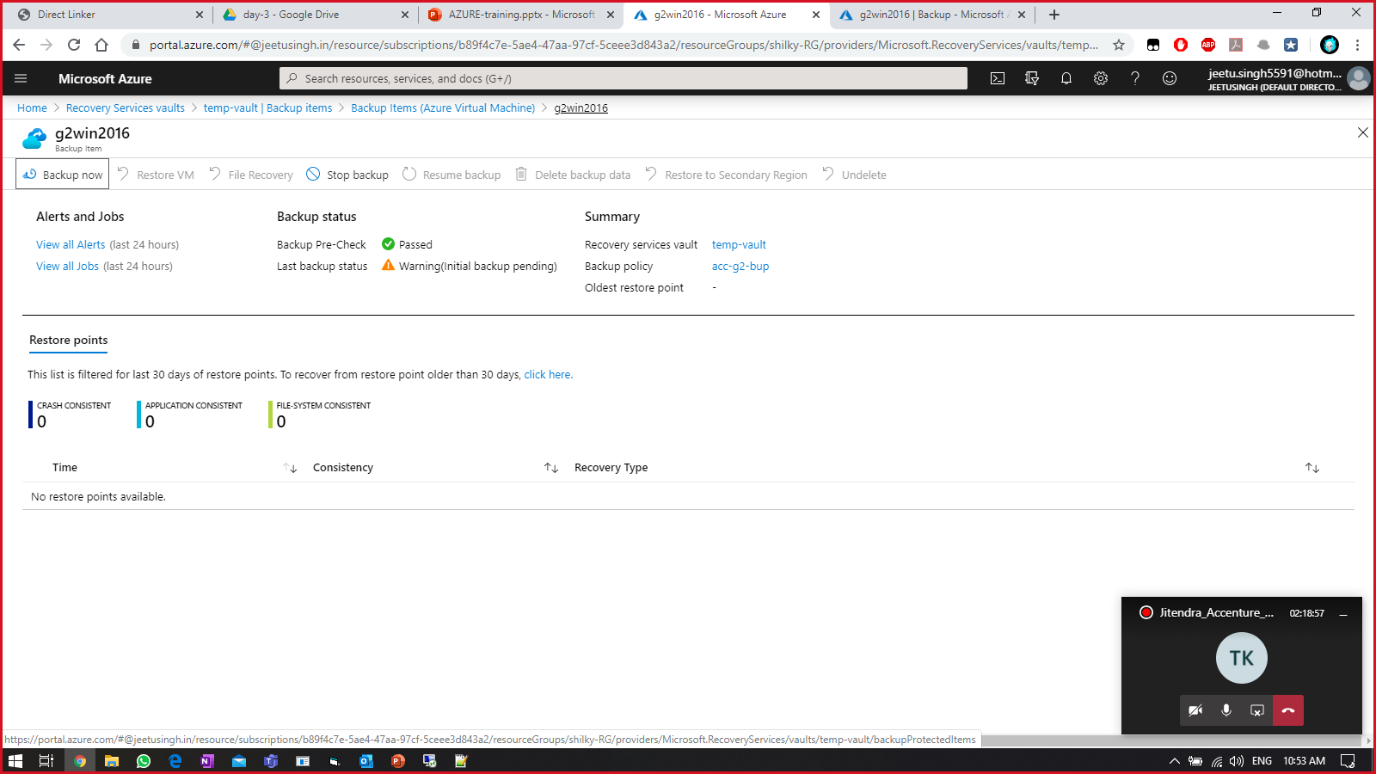

Select the backup time and click OK

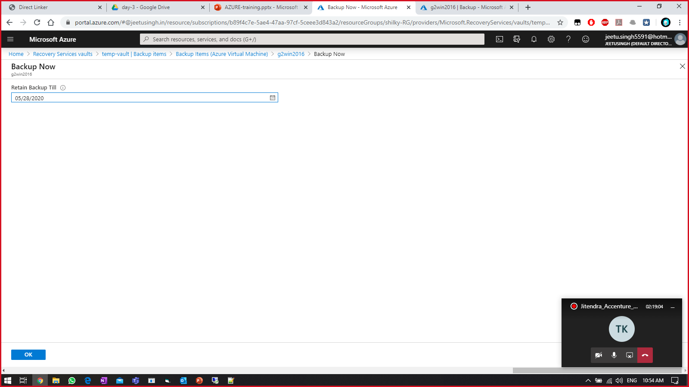

Something like this will be visible.

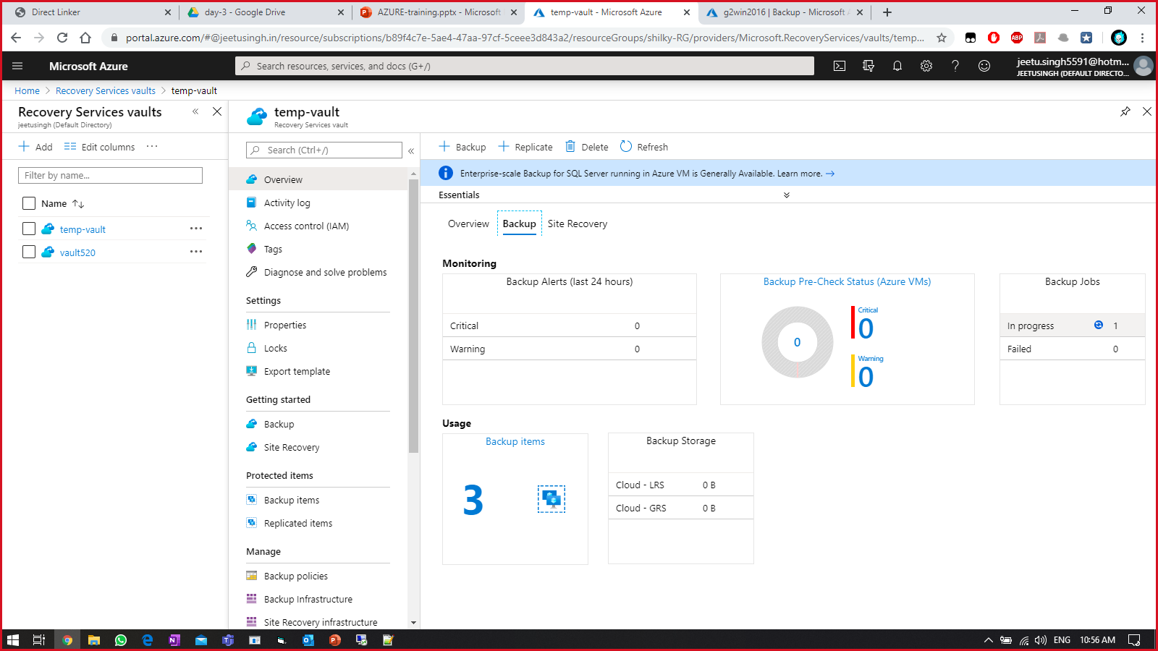

Practice Work No - 5:

|  |  |
| --- | --- |
| **Statement** | Implementing Azure App Service. |
| **Objective** | The main objective of the task is to create and manage Azure app service (website) using Azure portal. |
| **Outcomes** | After executing this, one should be able to create and manage the azure webapp. |
| **Prerequisites** | Working Azure account, Internet |

**[Task]: Create a new azure web app & access it over the internet. Change the data for the live website & verify it is getting updated.**

Select the “App service” on the azure portal by clicking on ellipses symbol.

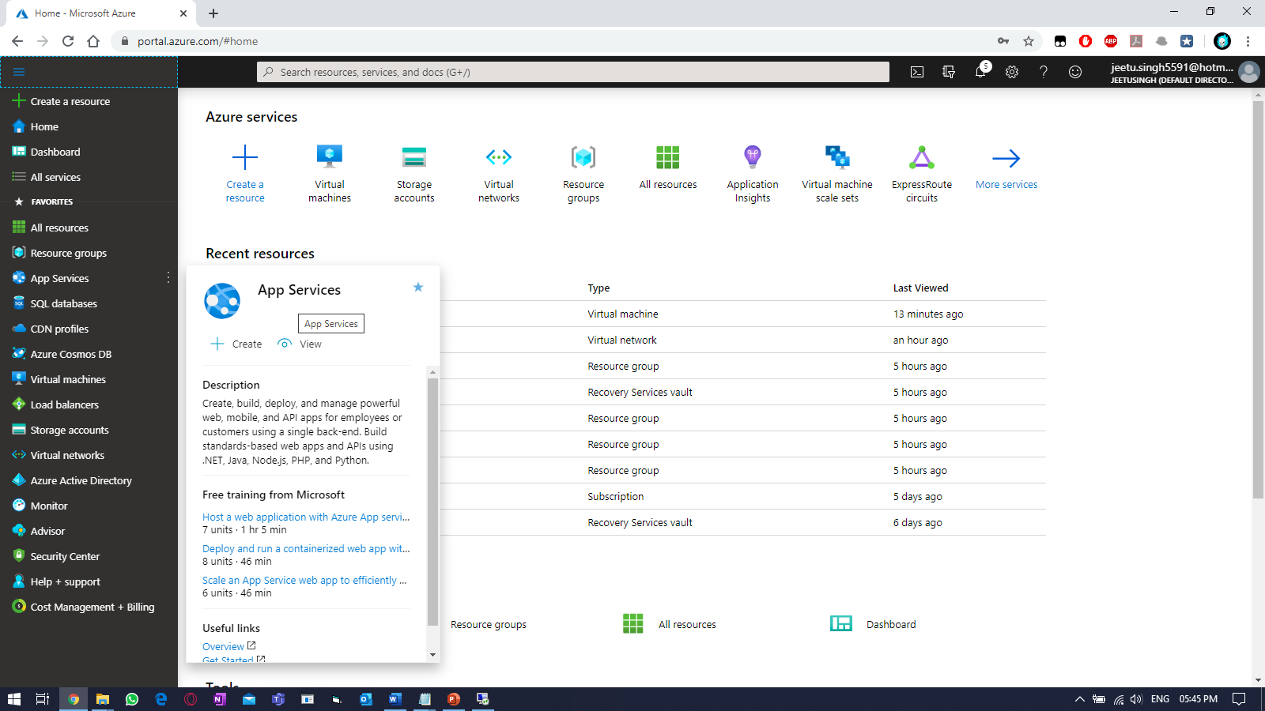

Create a new web app by filling the information, and select Monitoring.

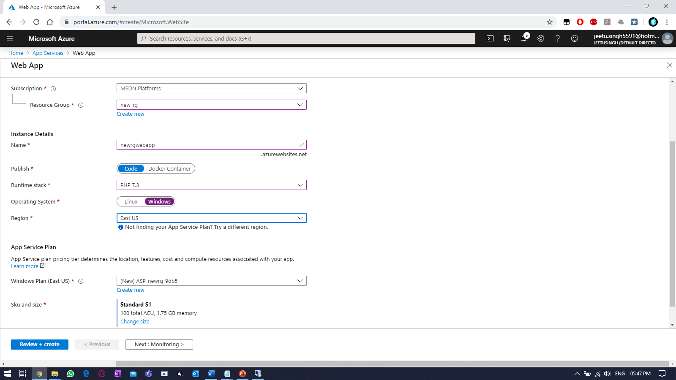

Enable Application Insights for monitoring web app (optional).

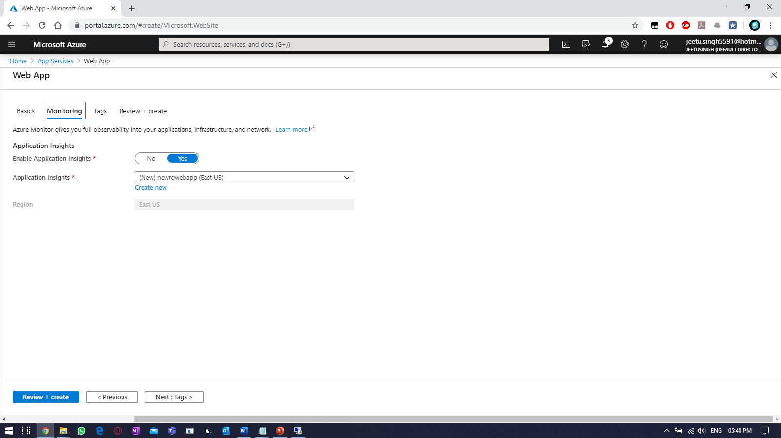

Select tag values,

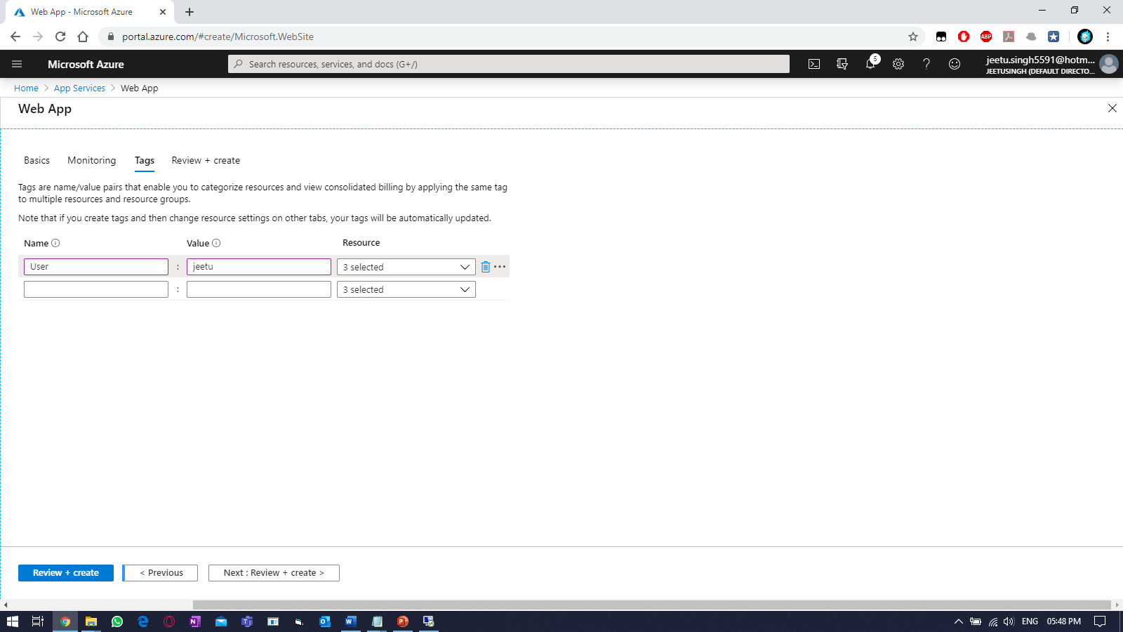

Click on “Create”, once validation is passed.

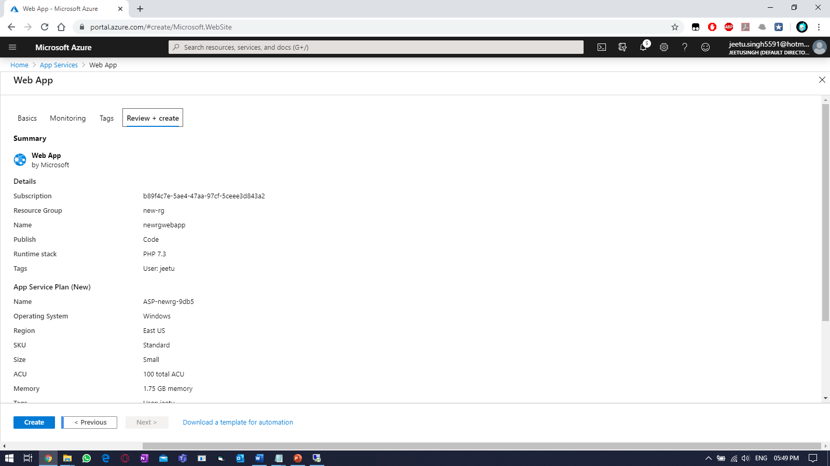

Click on “Go to resource”, once completed.

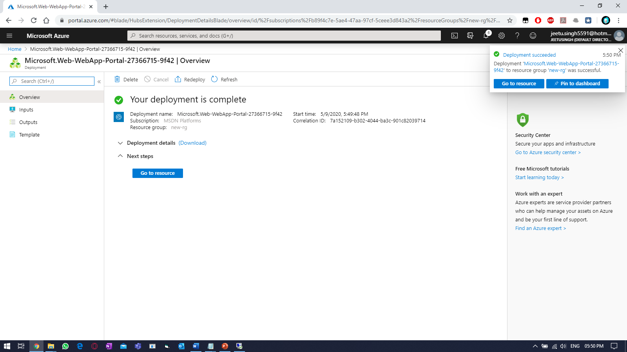

Browse to azure app service blade to access the website.

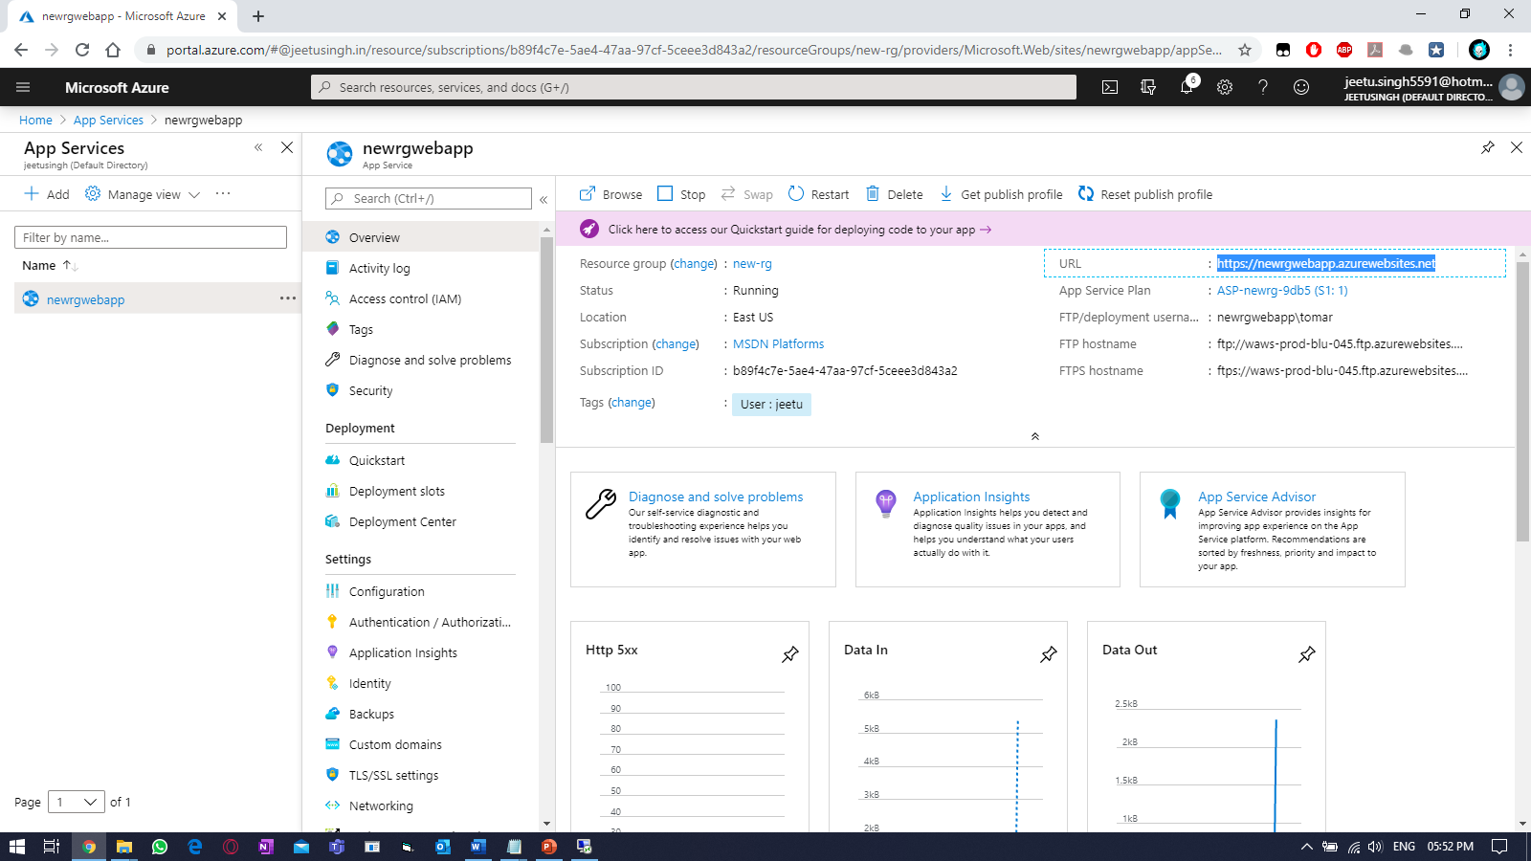

Verify the website, using the URL provided.

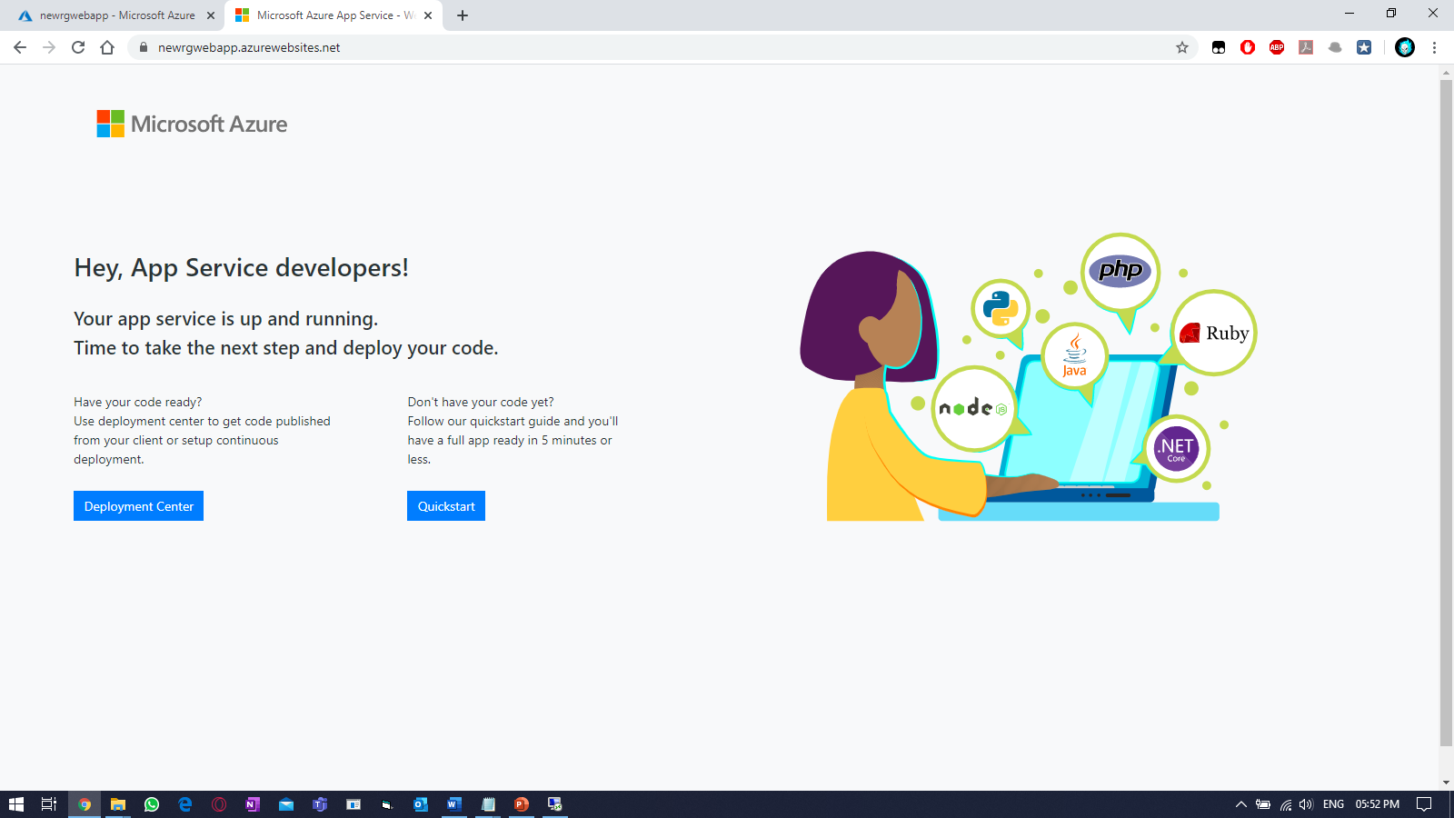

To edit the website (quick way). Go to “App Service Editor (Preview)”. And click on “GO🡪”

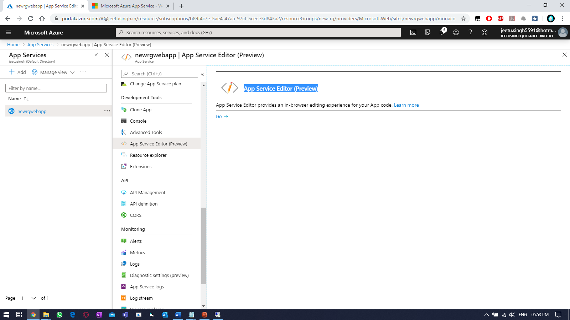

To modify the webpage, edit the “hostingstart.html”.

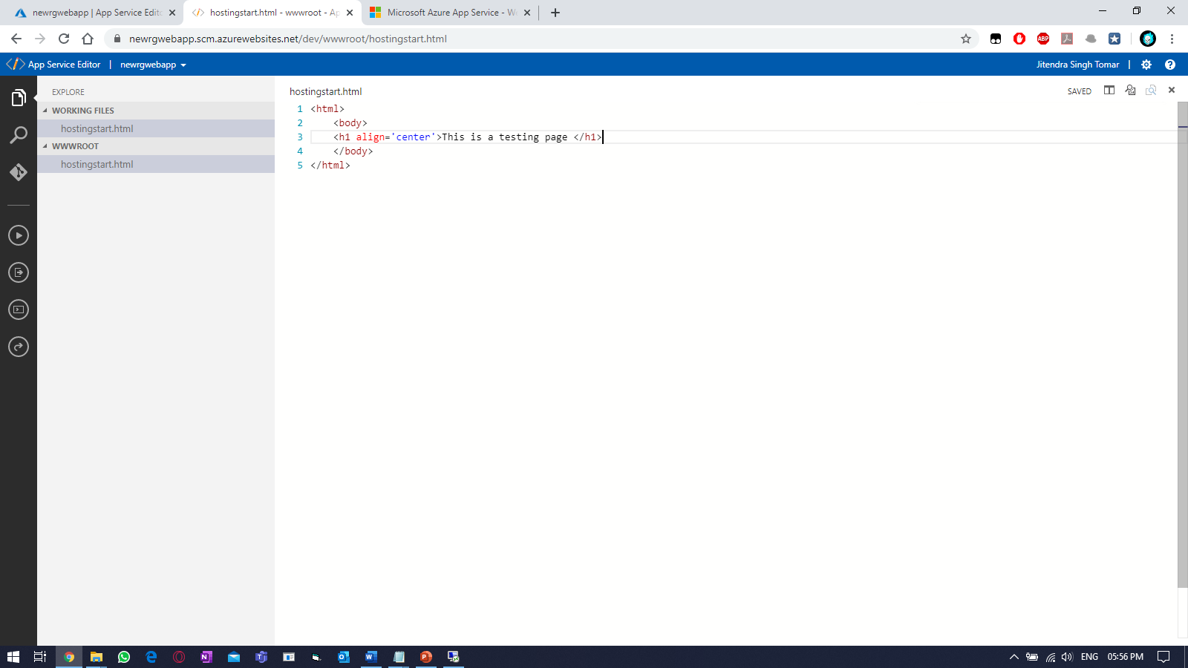

Refresh the webpage opened earlier.

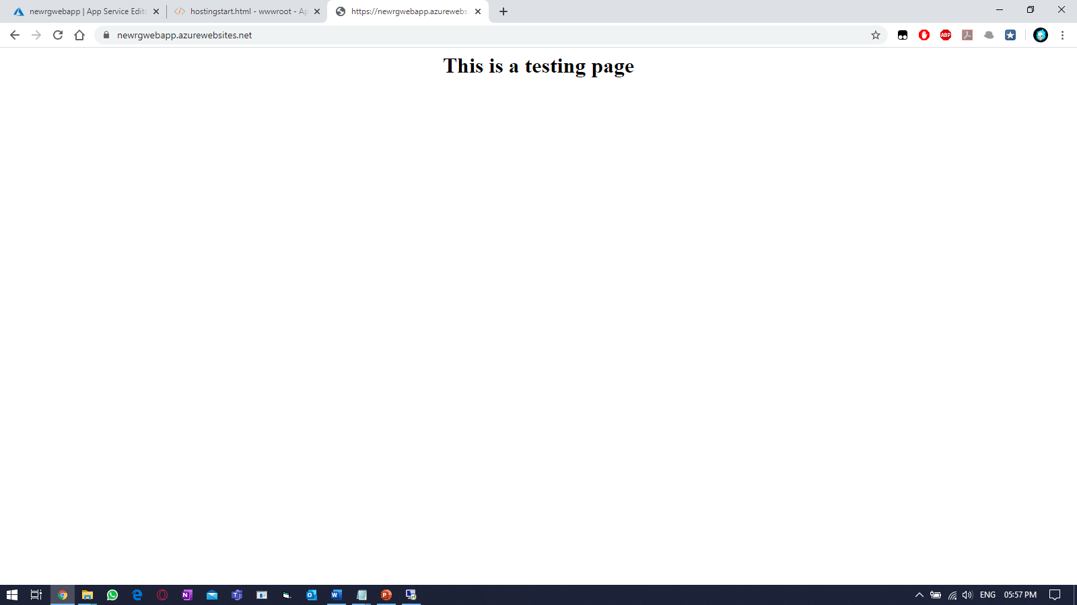

Practice Work No - 5:

|  |  |
| --- | --- |
| **Statement** | Implementing containers in Azure. |
| **Objective** | The main objective of the task is to create and manage Azure containers service using Azure portal. |
| **Outcomes** | After executing this, one should be able to create and manage the azure containers. |
| **Prerequisites** | Working Azure account, Internet |

**[Task]: Create a new website using Azure container service.**

Select the Create a resource > Containers > Container Instances.

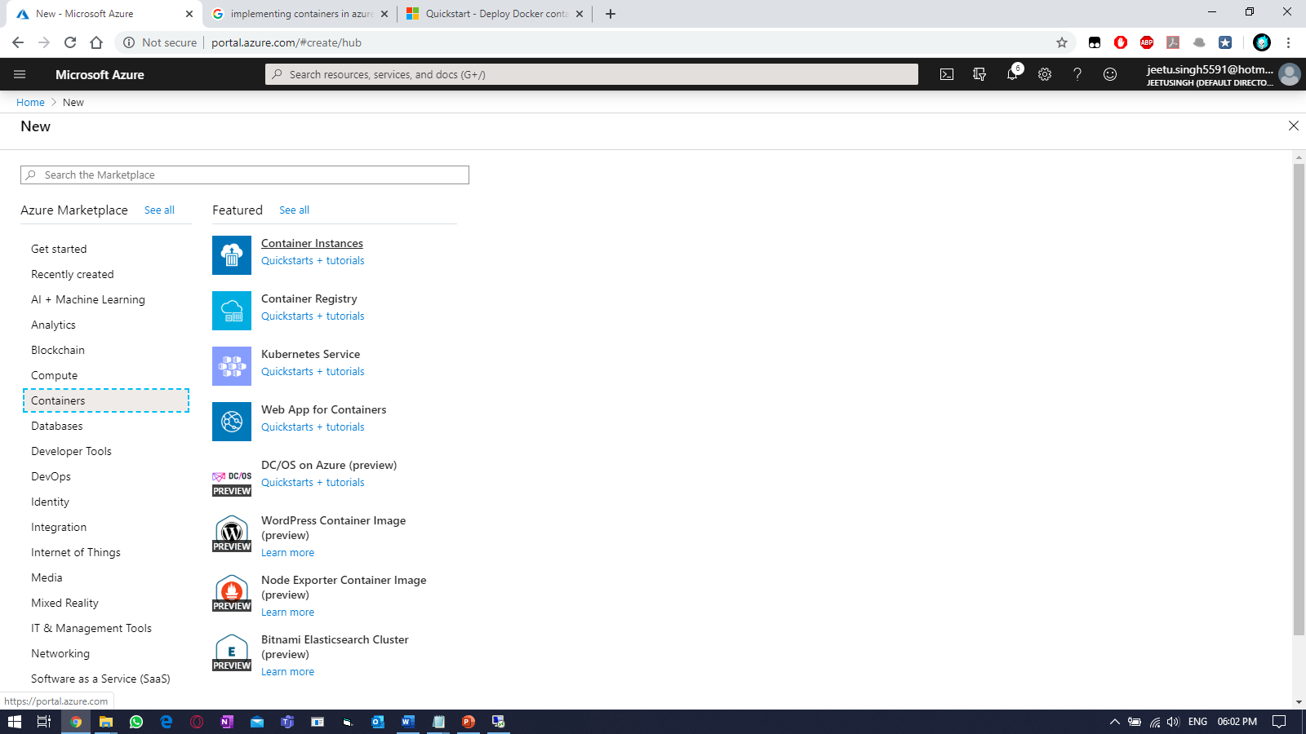

Fill the required details using default Linux based image.

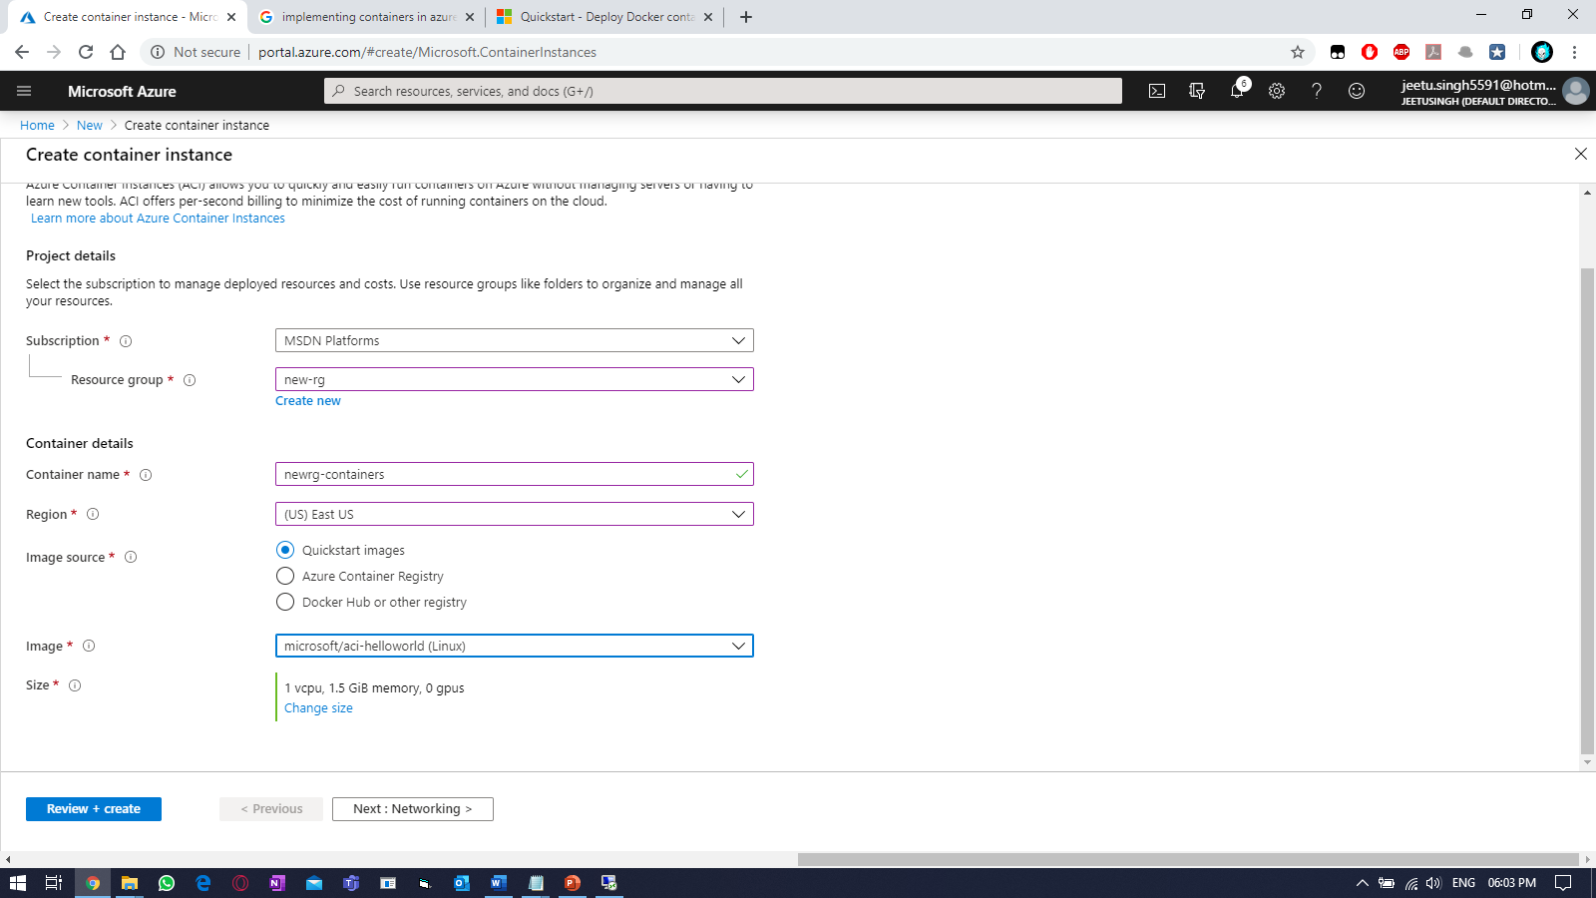

Provide the DNS label for global access.

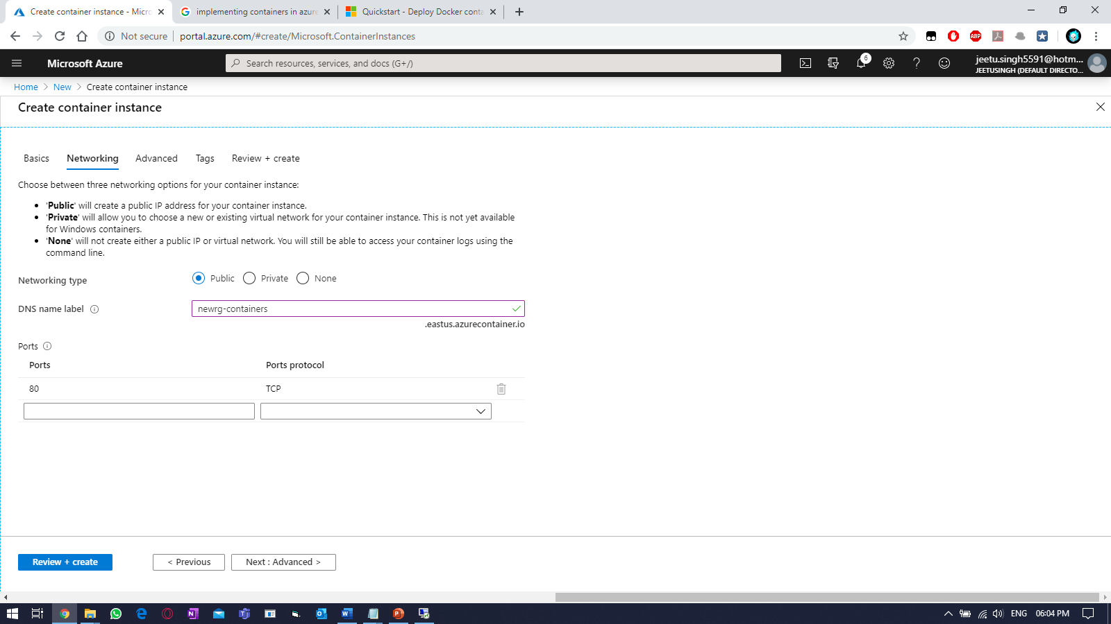

Select “Review + Create” and click “Create”



Select “go to resource”

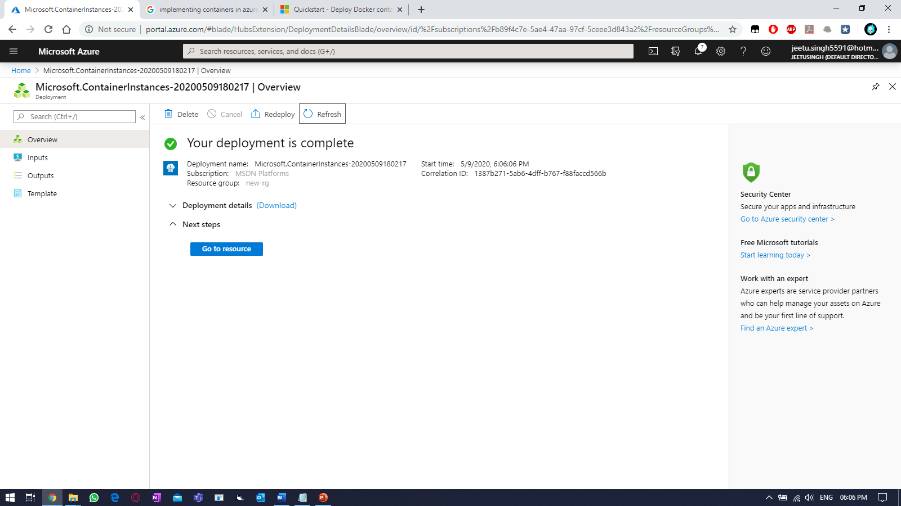

Once status is “Running”, select FQDN.

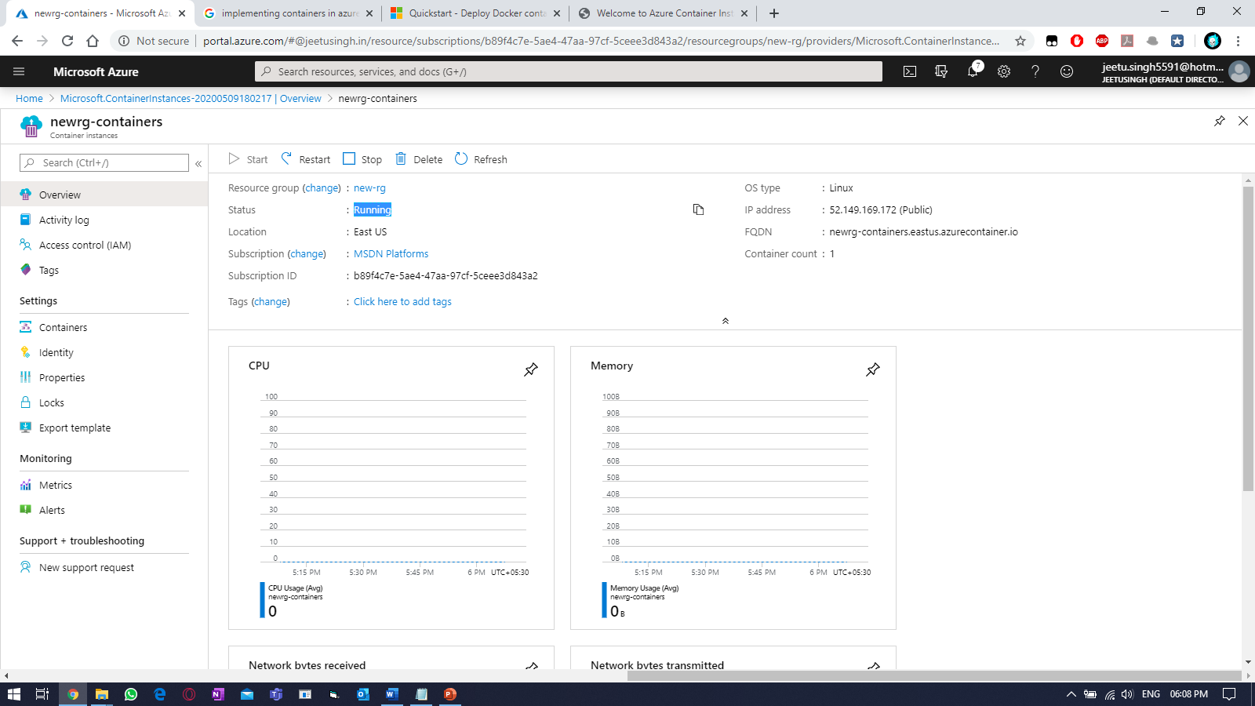

Access it using web browser

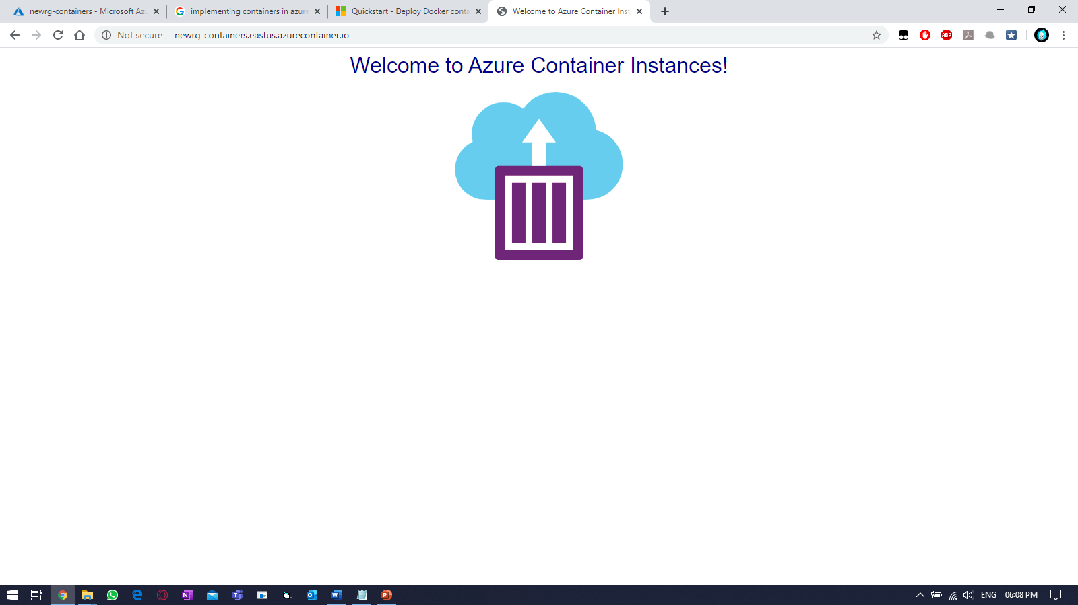

Practice Work No - 6:

|  |  |
| --- | --- |
| **Statement** | Implementing Azure Active Directory. |
| **Objective** | The main objective of the task is to create and manage Azure Active Directory using Azure portal. |
| **Outcomes** | After executing this, one should be able to create and manage the azure Active Directory. |
| **Prerequisites** | Working Azure account, Internet |

**[Task]: Create users in bulk using Active Directory on portal.**

Switch to azure active directory blade & select Users blade.

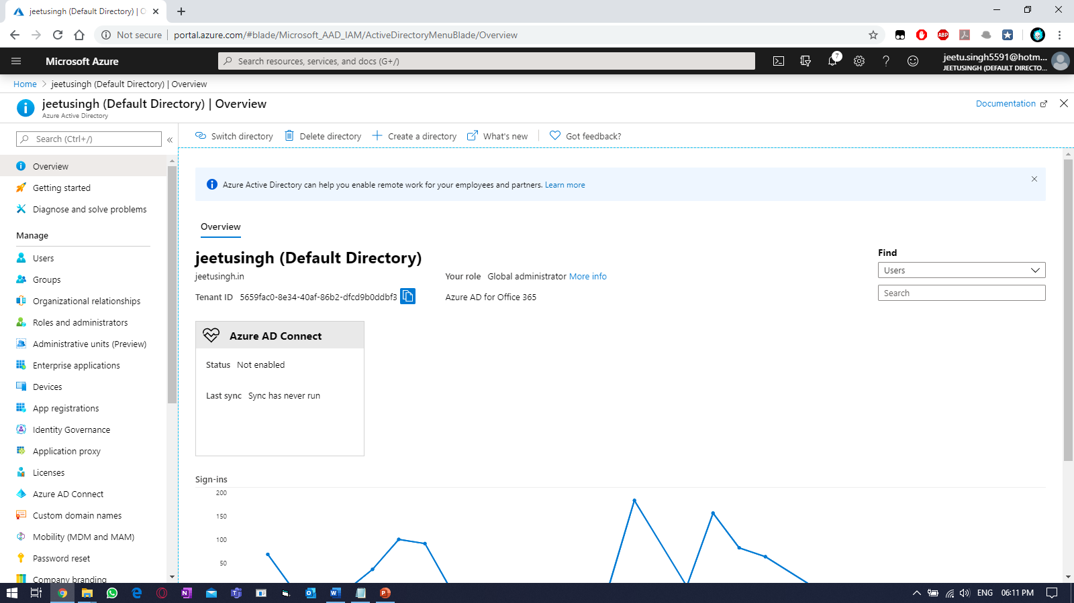

Under USERS, select “Bulk Create” tab.

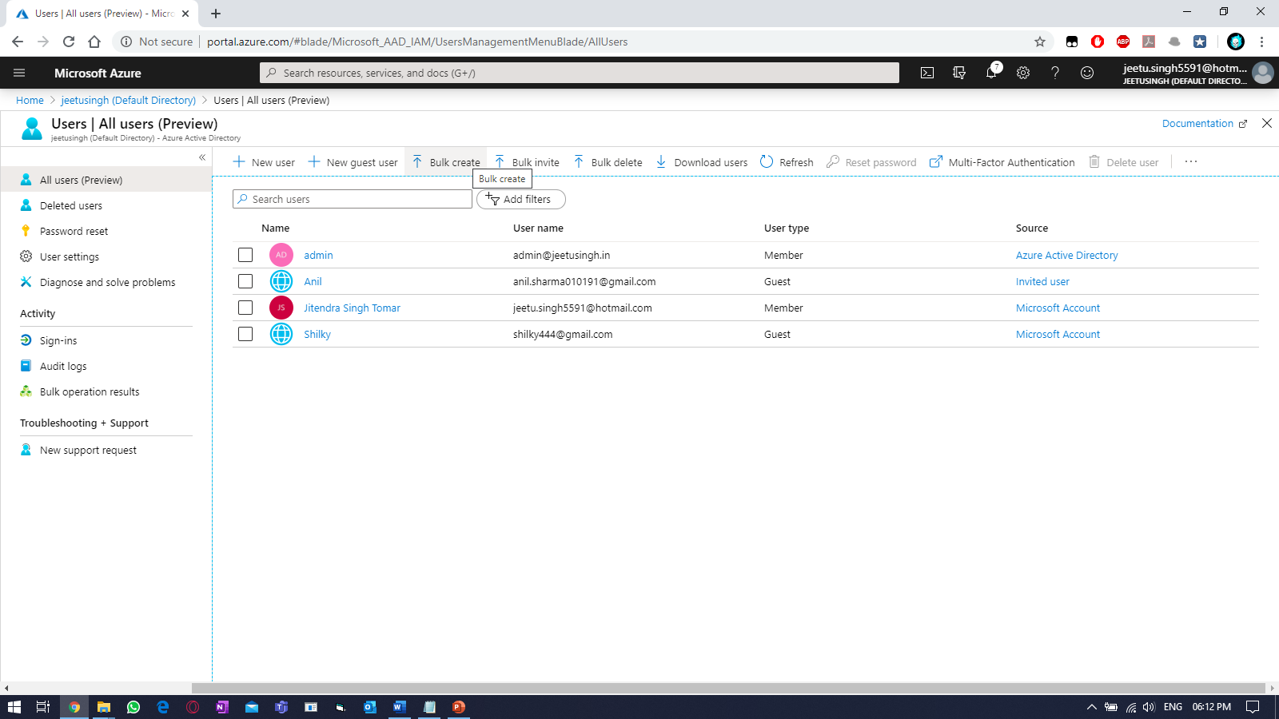

Download the default CSV and edit the content & upload it from the same portal.

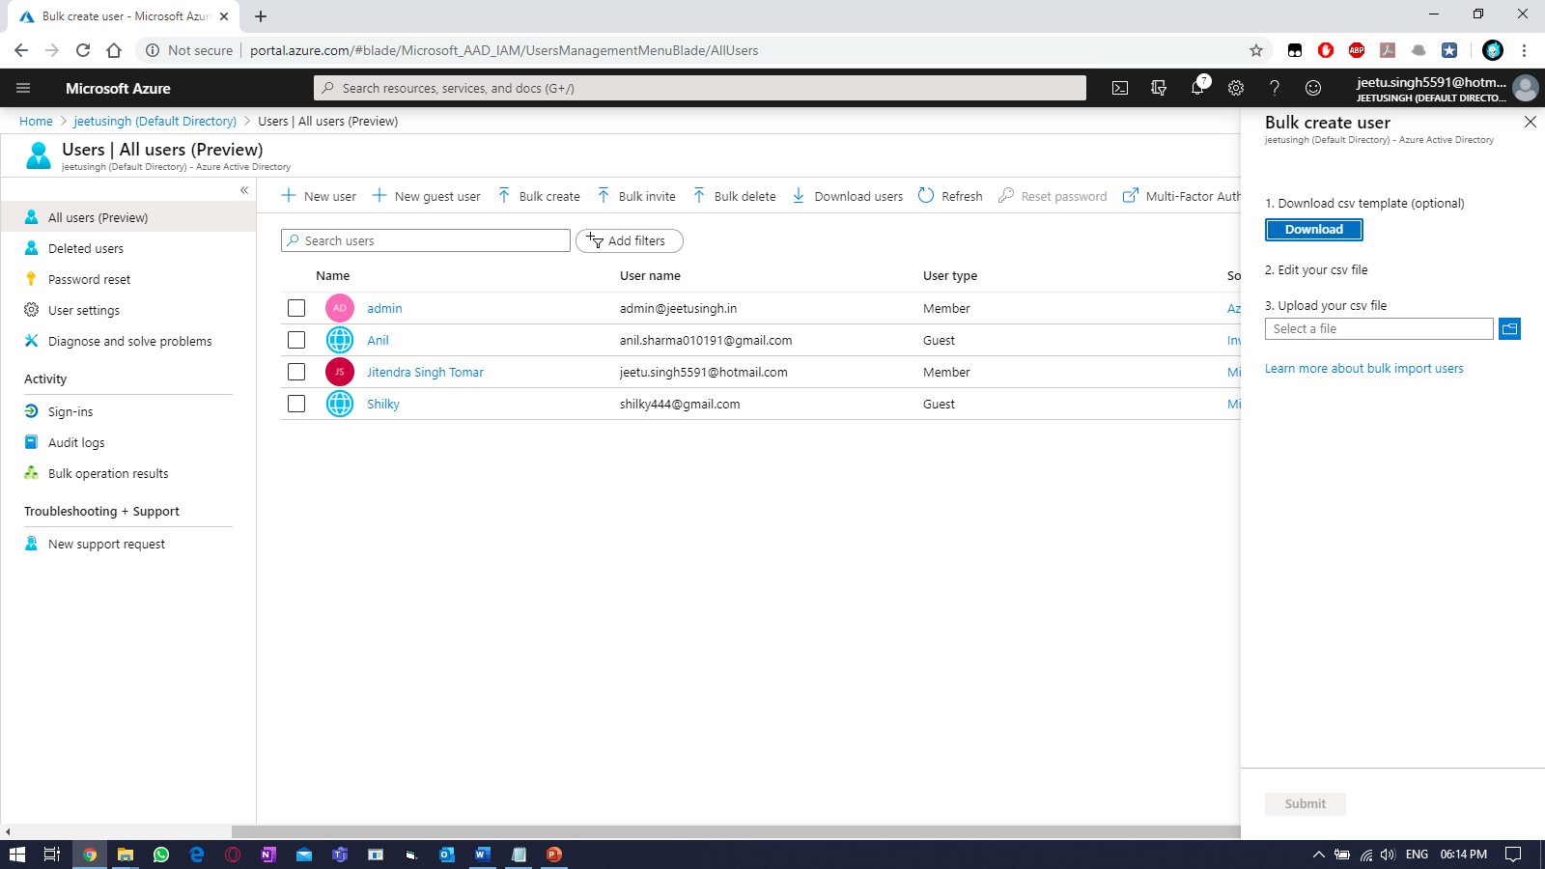

Editing the CSV.

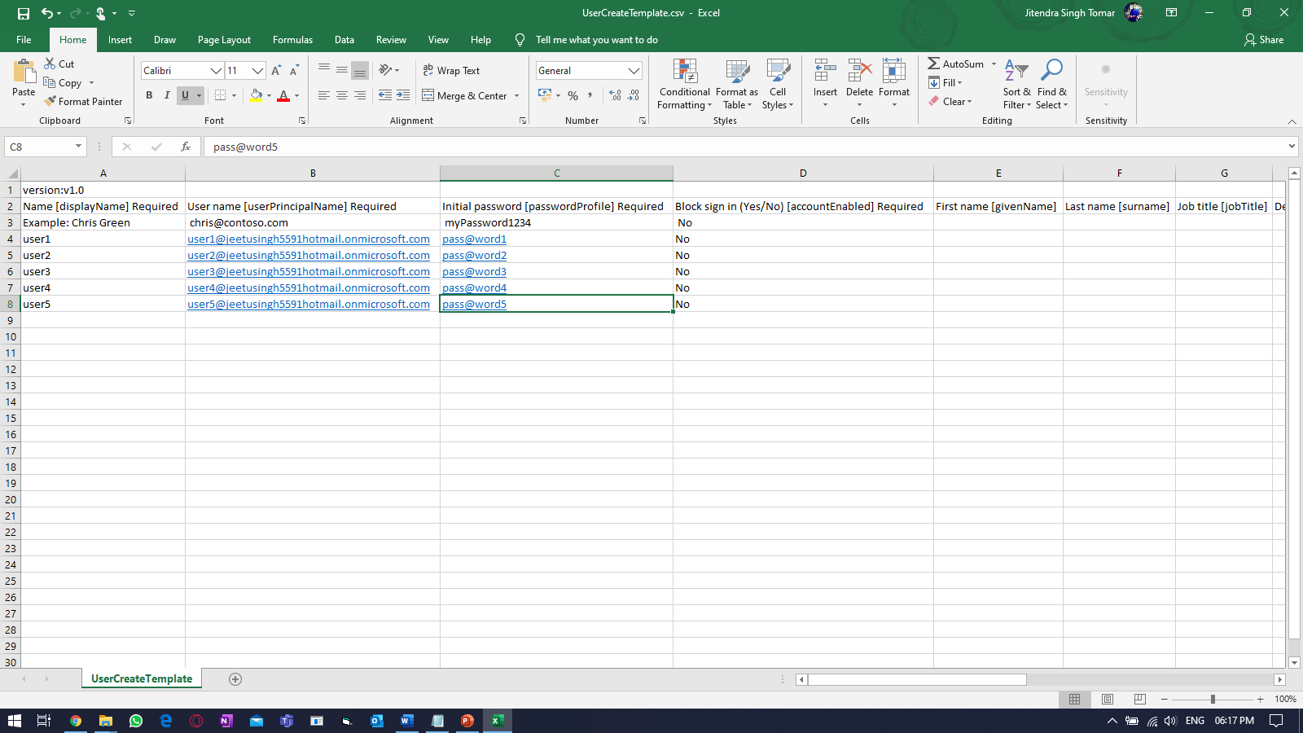

Uploading the CSV.

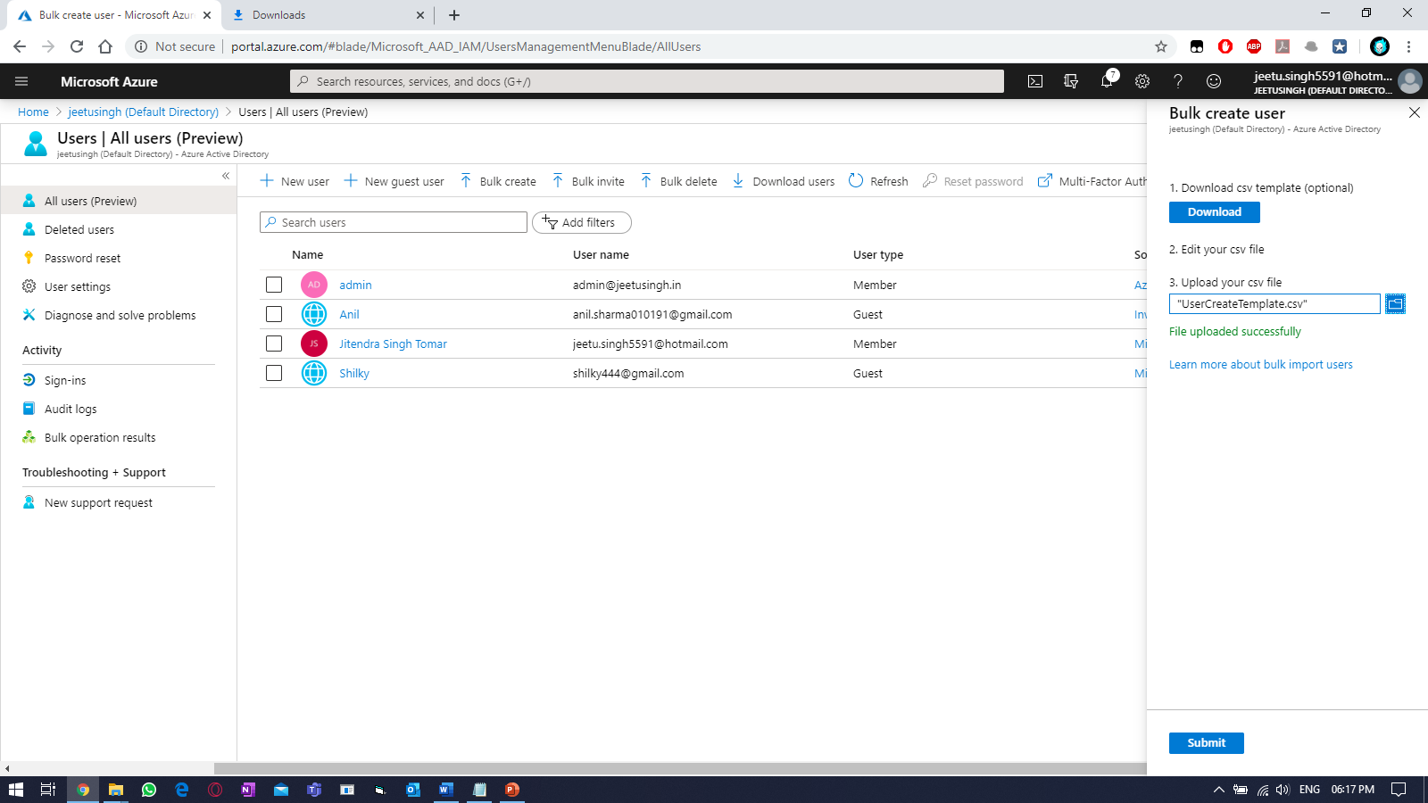

Refresh the azure portal.

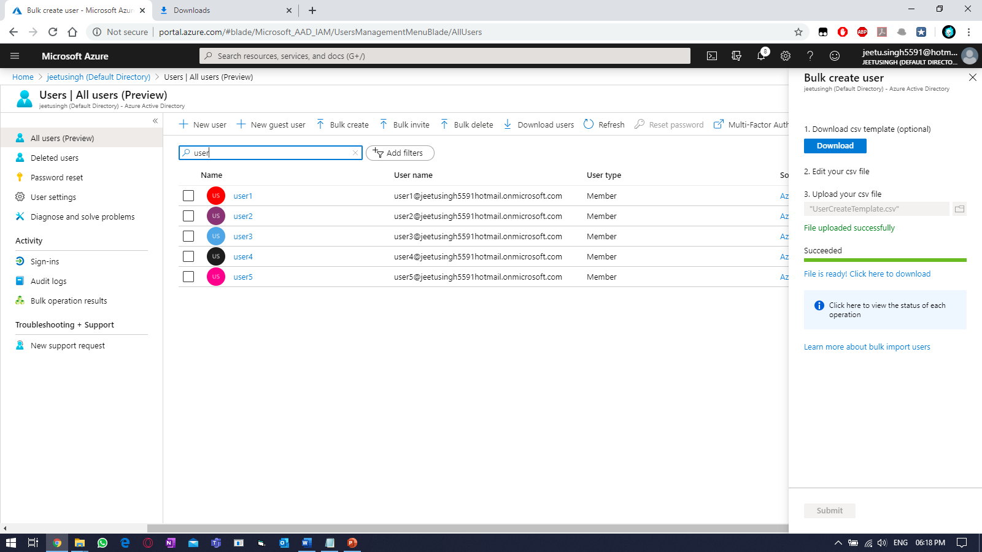

Login-in using the newly created user.

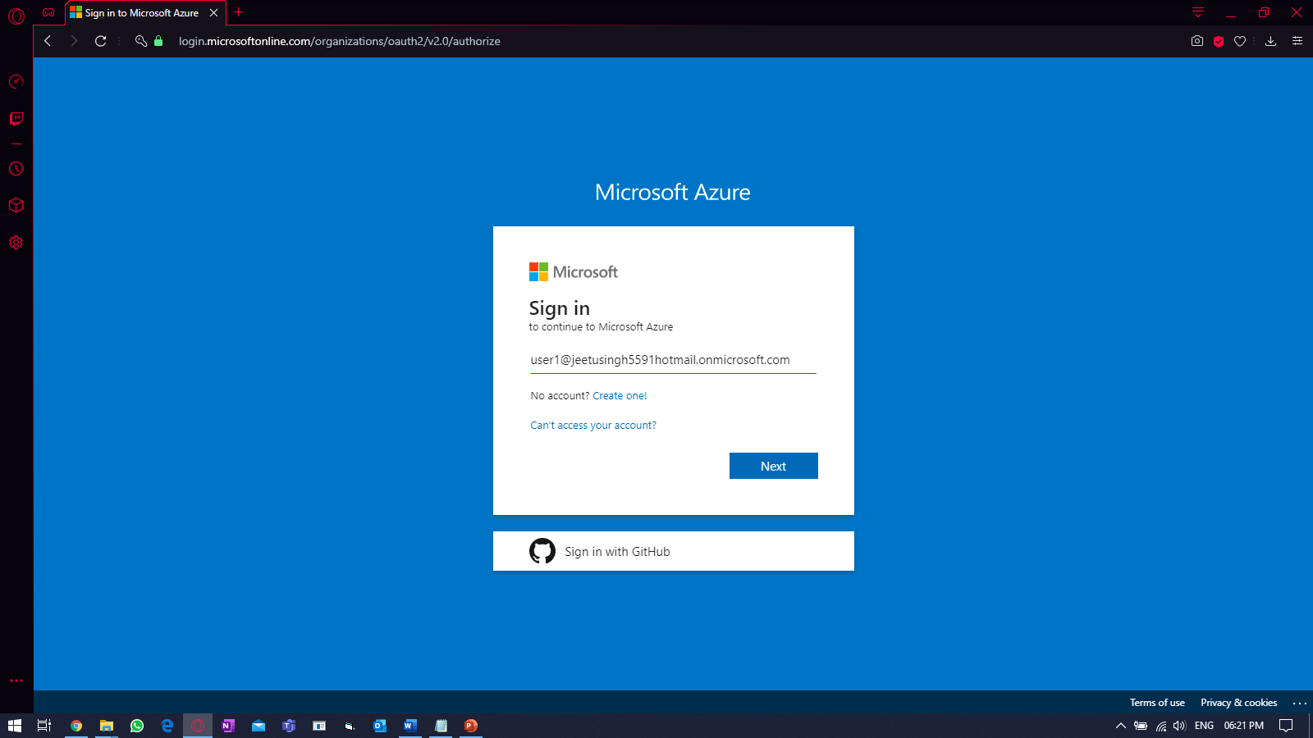

Providing password.

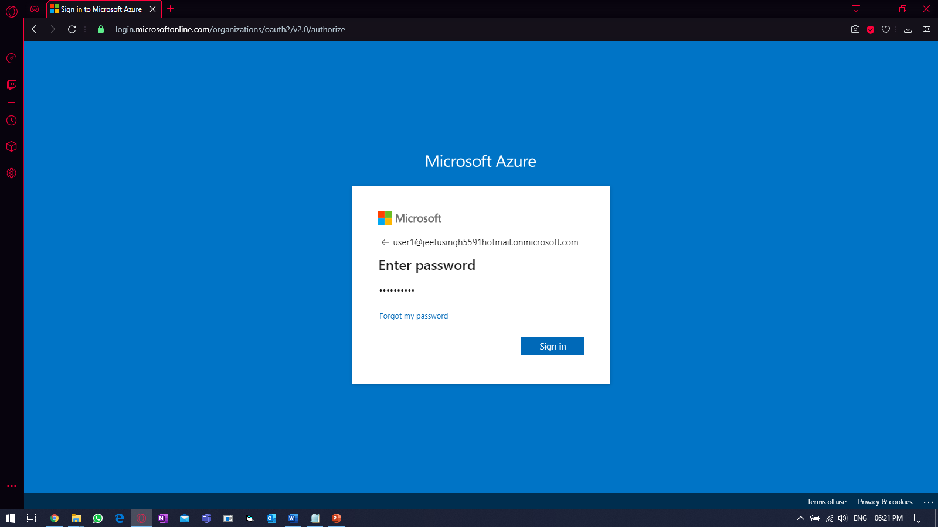

Providing new password

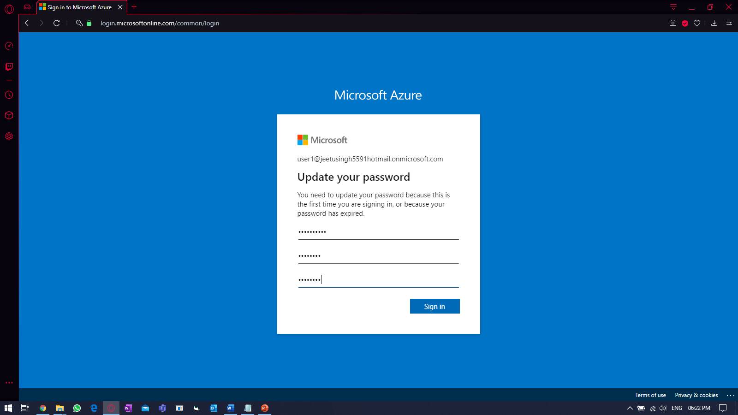

Login-in to portal.

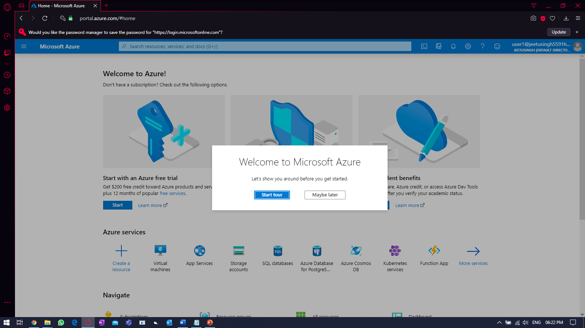

Practice Work No - 7:

|  |  |
| --- | --- |
| **Statement** | Implementing Azure Cloud Services. |
| **Objective** | The main objective of the task is to create and manage Azure Cloud Services using Azure portal. |
| **Outcomes** | After executing this, one should be able to create and manage the azure Cloud Services i.e. CDN to faster content delivery. |
| **Prerequisites** | Azure storage account, Internet |

**[Task]: Create a content delivery network (CDN) as a part of Azure cloud service using existing storage account (Ex: jeetusto1).**

Go to your Storage account & select container, else create a new container if it’s not present.

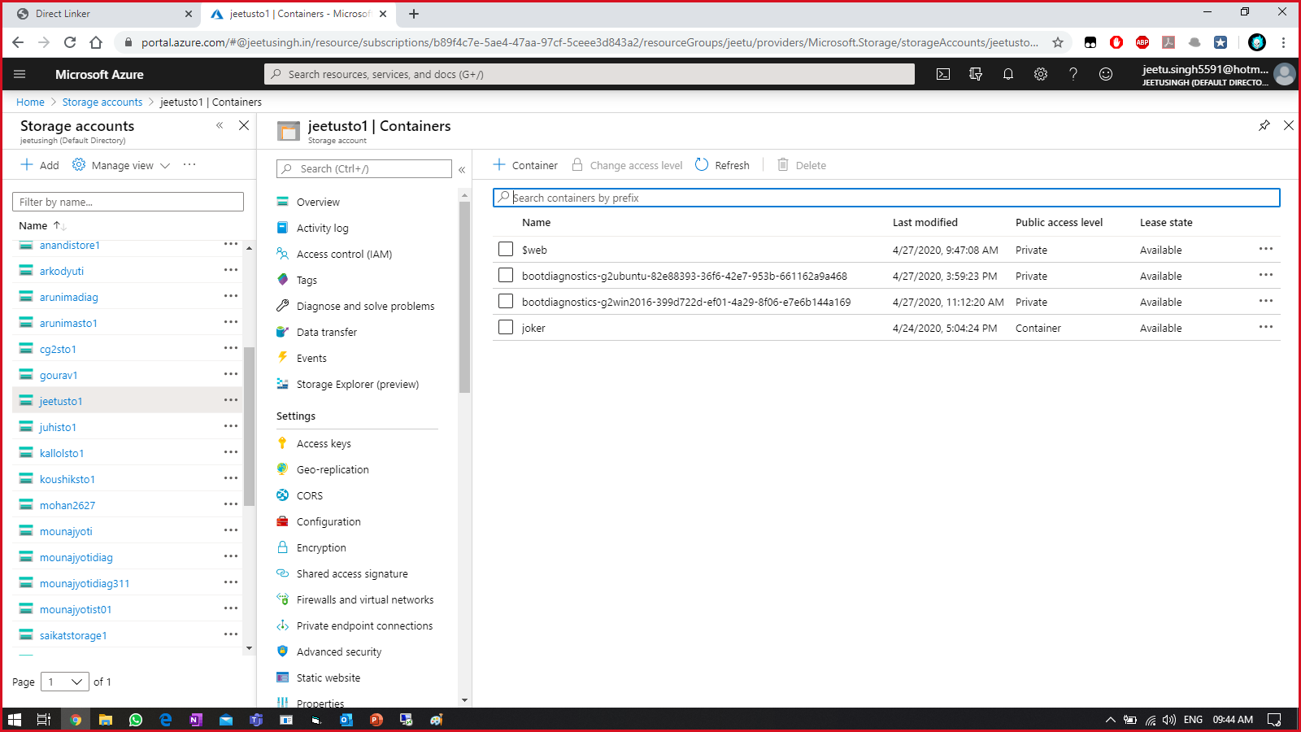

Create a new container with any name

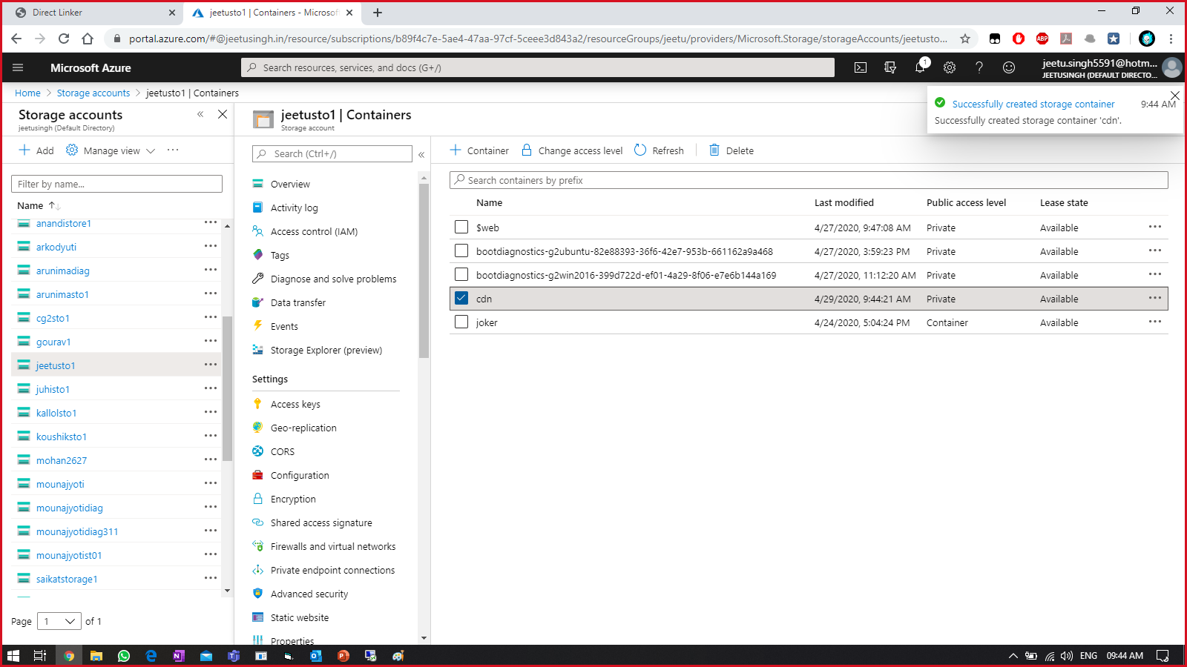

Upload some files in the container.

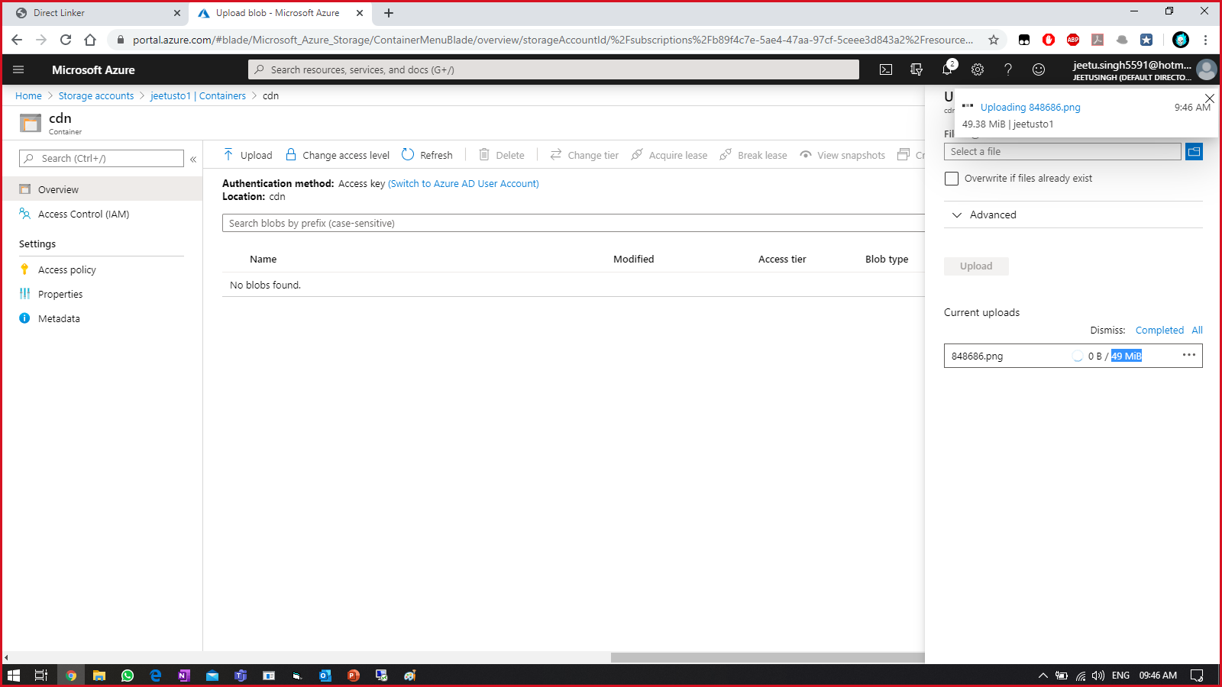

Now in the search bar, Search for CDN in portal.

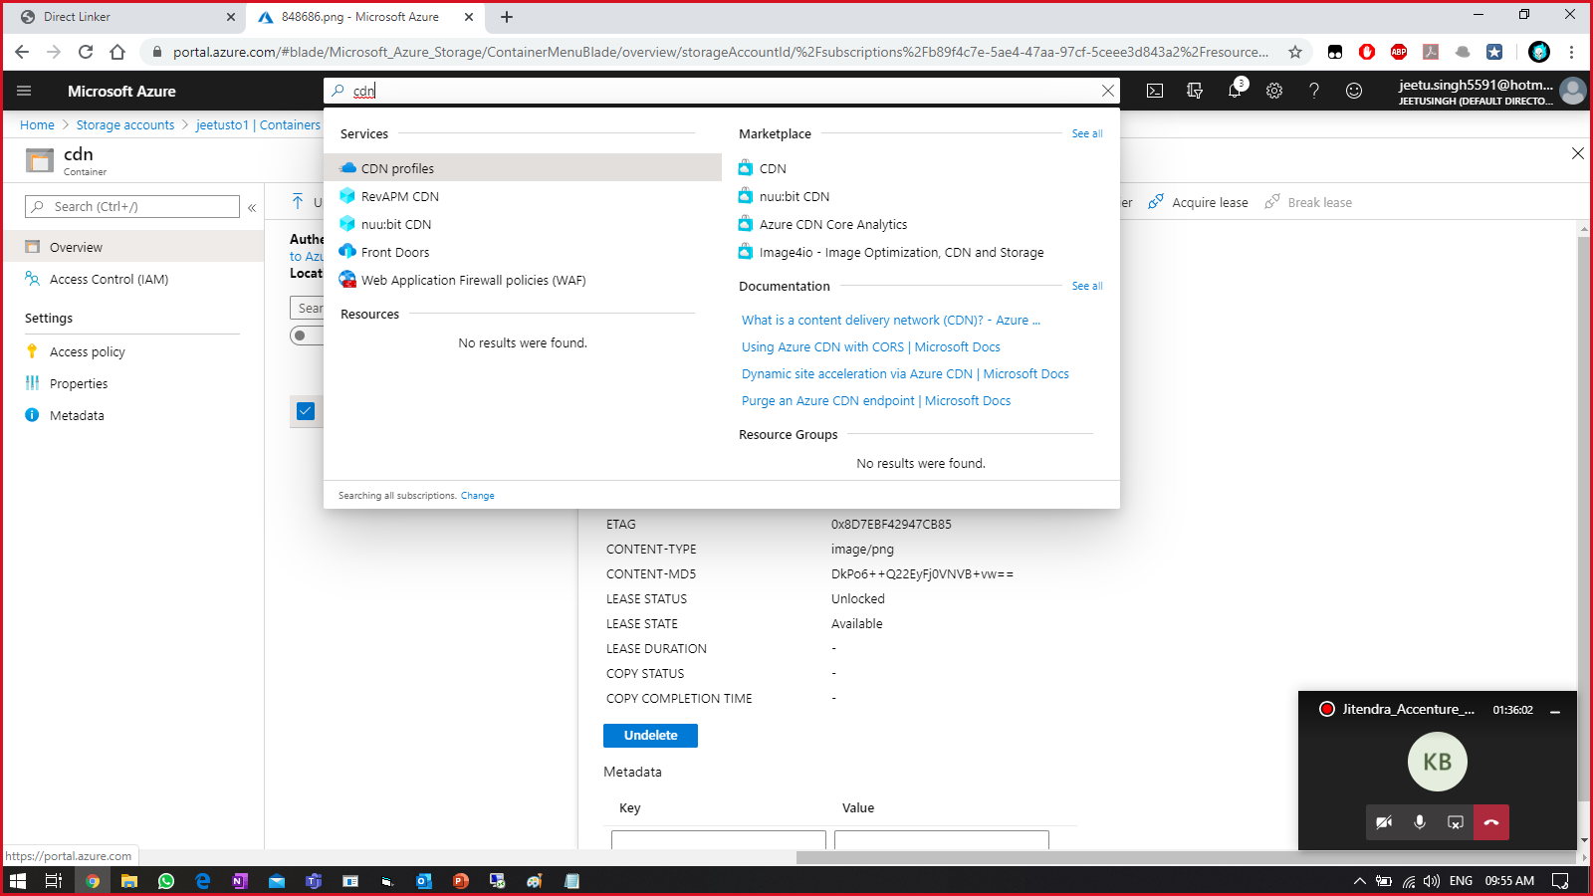

Fill details required to create CDN profile.

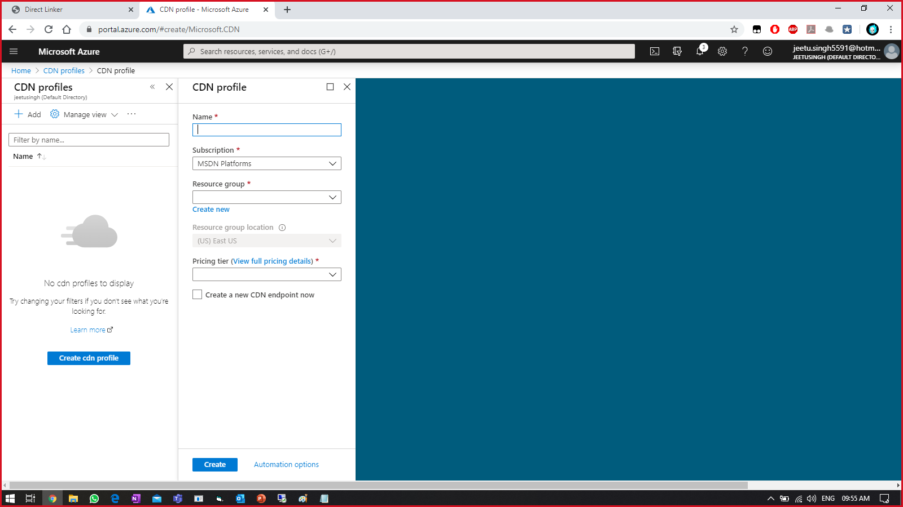

Enable “Create a new CDN endpoint now” & Provide a CDN endpoint name

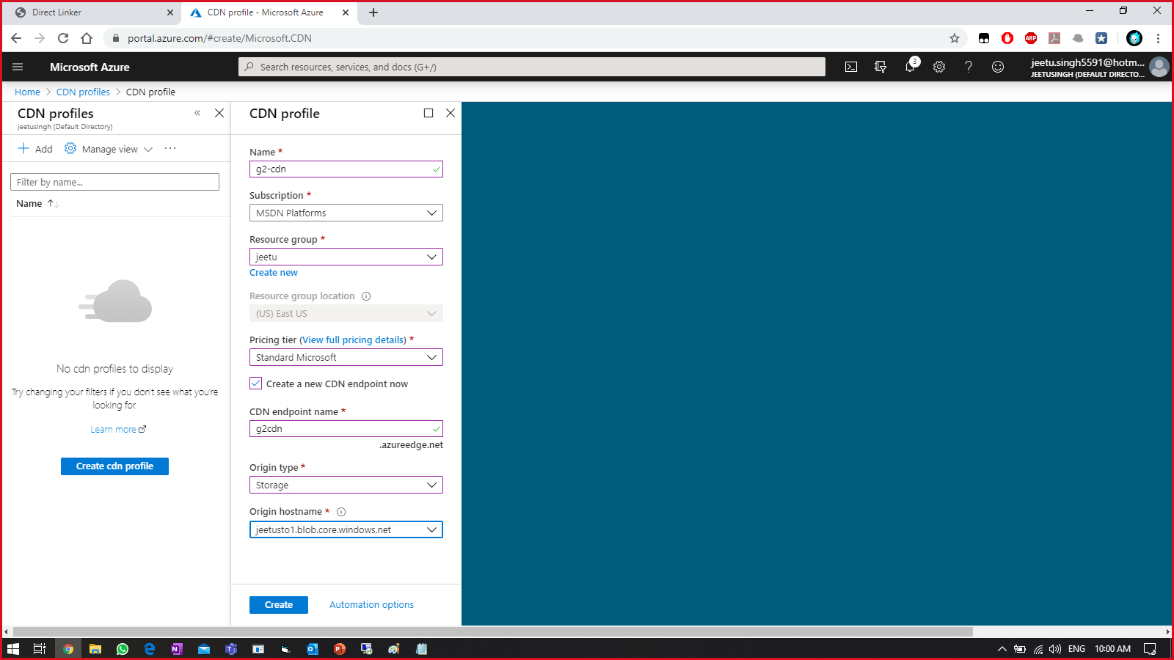

Once created, select the endpoint name.

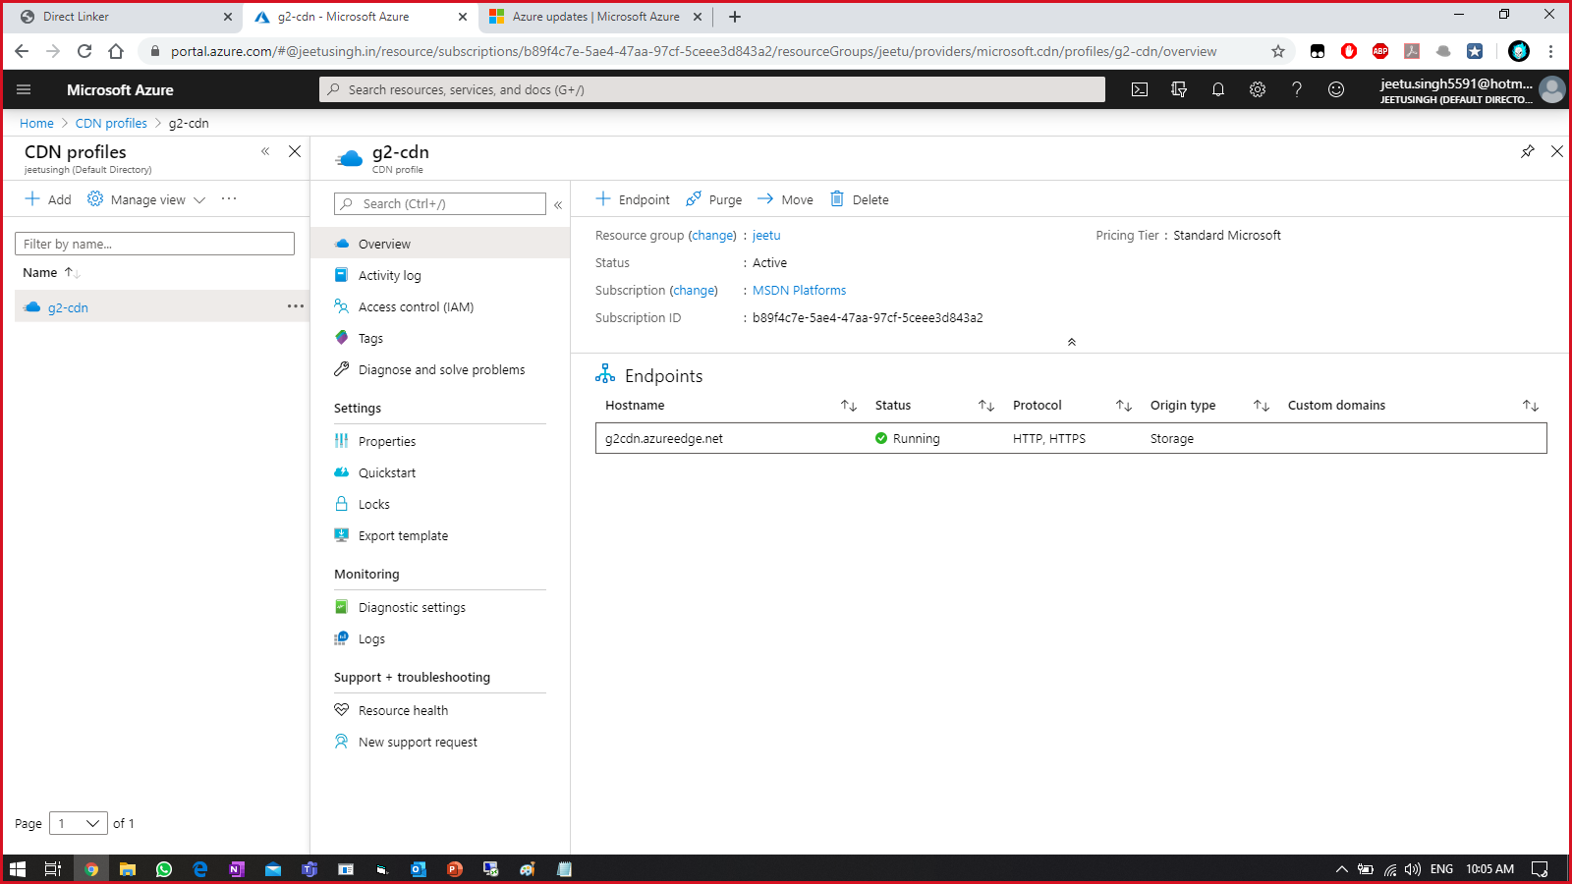

Copy endpoint hostname & paste it in the web browser.

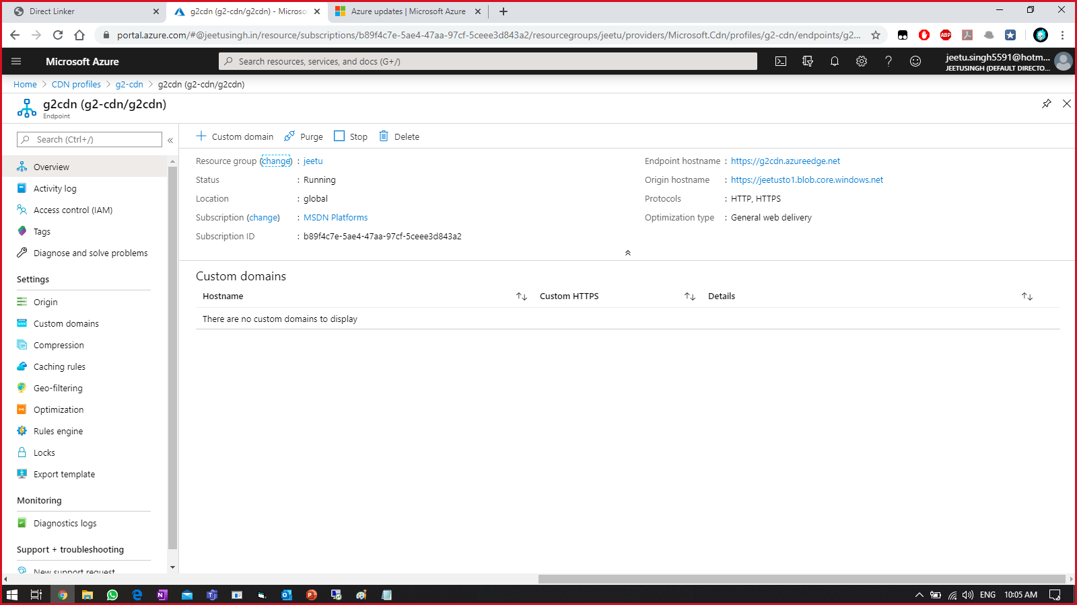

An image (uploaded earlier) of approx. 50MB will take little time to get displayed.

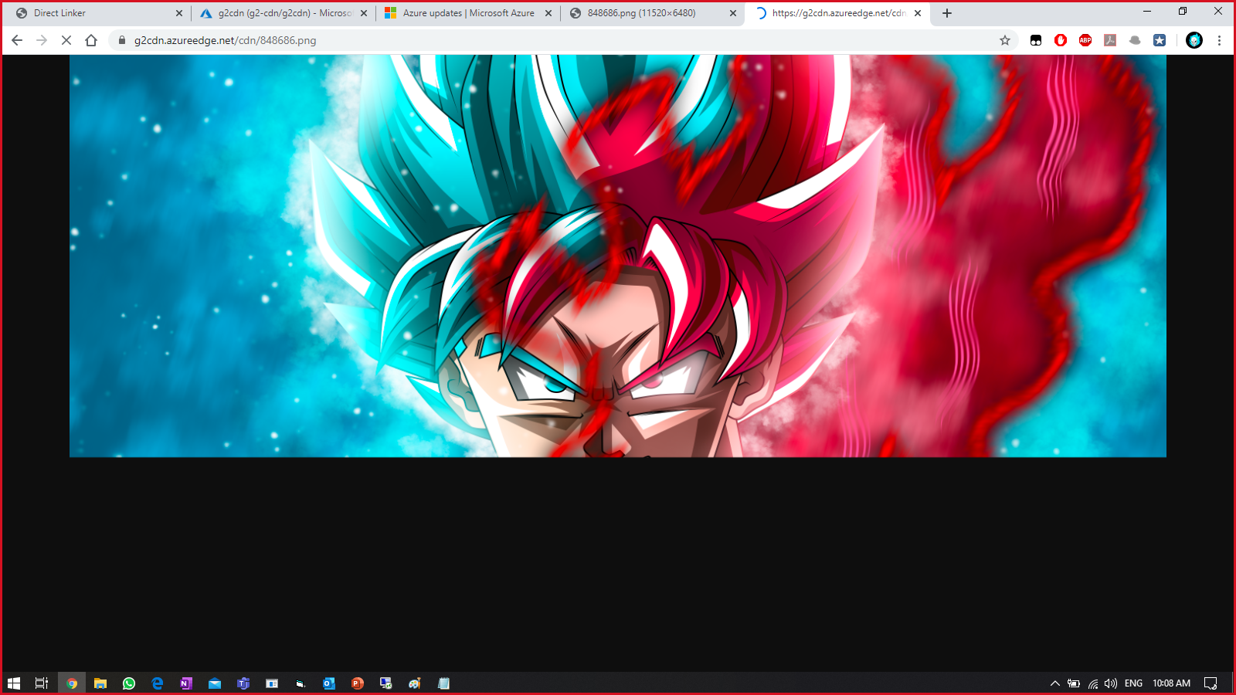

Try accessing the same URL multiple time. This time it must be little faster as compared to earlier.